Apple Tart serves 4
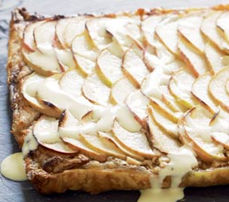
Ingredients
1 sheet puff pastry, thawed and cut in half
60g butter, softened
60g caster sugar
1 egg
60g almond meal
30g plain flour
½ tsp ground cinnamon
2 pink lady apples, thinly sliced

2 tsp caster sugar, extra

Method
- Preheat your oven to 200°C.
- Use a fork to prick the pastry all over.
- Using a small bowl, cut 4 circles out of the pastry.
- Press pastry into the base and sides of 4 mini pie tins.
- Meanwhile, using a wooden spoon beat the butter and sugar in a bowl until well combined.
- Add the egg and beat until just combined.
- Add the almond meal, flour and cinnamon and stir with a wooden spoon to combine.
- Divide the mixture between the four prepared pastry cases and smooth down the surface.
- Arrange apple slices over the pastry and filling. Sprinkle evenly with the extra sugar.
- Bake in the oven for 25-30 minutes.

