Oven Baked Nuggets and Chips
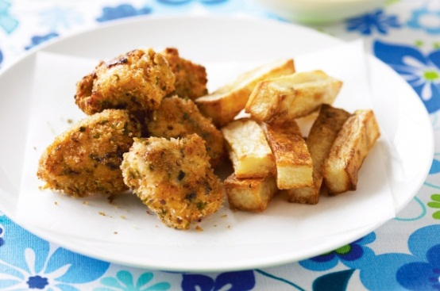
Ingredients
Chicken Nuggets
200g chicken breast fillets, cut into 3cm pieces
¼ cup buttermilk
¼ cup cornflake crumbs, crushed
¼ tsp sweet paprika
¼ tsp garlic salt
¼ tsp dried mixed herbs
⅛ tsp cracked black pepper
Chips
1 medium potato
Olive oil cooking spray
Method
- Preheat oven to 220°C.
- Line a baking tray with baking paper.
To make wedges:
- Cut the potato into wedges, and rinse well under cold water to remove the starch, dry thoroughly with paper towel.
- Place wedges on the oven tray and spray lightly with oil and sprinkle with salt.
- Bake for 25-30 minutes.
To make nuggets:
- Place chicken in a small glass bowl. Add the buttermilk and toss to coat.
- Combine cornflake crumbs, paprika, garlic salt, herbs and pepper in a zip lock bag.
- Add the chicken to the bag and shake until all the chicken pieces are coated.
- Spread coated chicken on the lined oven tray and spray lightly with oil.
- Bake for 12-15 until golden.

