Tropical Crush
serves 2
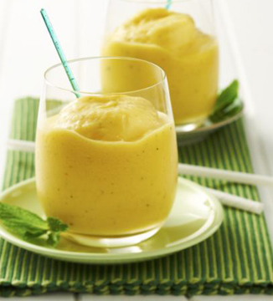
1 cup (240g) passionfruit yoghurt
1 cup (200g) crushed pineapple in natural juice
2 mango cheeks (fresh or tinned) or 200g frozen
4 fresh mint leaves
2 cups ice

1. Put all the ingredients in a blender and mix until smooth and thick.

2. Pour into 2 chilled glasses and serve with a thick straw and spoon.

