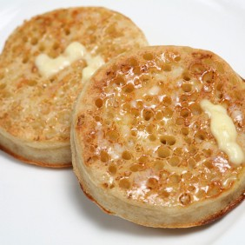
Crumpets
Make in pairs
1 cup plain flour
2 tsp baking powder
½ tsp salt
½ tsp sugar
¾ cup lukewarm water
2 tsp (1 sachet) dry yeast

1. Combine the flour, baking powder, salt and sugar together in a large bowl.
2. In a small jug dissolve the yeast in the warm water, and then add to the flour mix.
3. Beat with a whisk or wooden spoon until smooth.
4. To cook your crumpets, heat a frying pan over a low heat, place lightly greased egg rings in the pan and third fill with mixture and cook for approximately 8-10 minutes or until the surface is covered with holes, cover and cook for 2-3 minutes.

