Blueberry Banana Bread

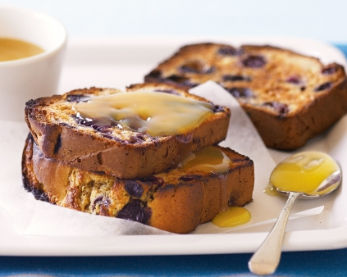
Ingredients
130g self-raising flour
20g plain flour
70g brown sugar
95g overripe banana, mashed
60ml milk
1 egg, lightly whisked
25g butter, melted, cooled
½ teaspoon vanilla essence
125g blueberries (fresh or frozen)

Method
- Preheat oven to 180°C.

- Lightly spray 2 mini loaf pans with oil.
- Combine flour and sugar in a large bowl.
- In a small bowl, combine the mashed banana, milk, egg, butter and vanilla.
- Add the banana mixture and blueberries to the flour mixture and stir until just combined.
- Spoon the mixture into the prepared pans and smooth the surface.
- Bake in the oven for 30-35 minutes or until a skewer inserted into the centre comes out clean.
- Set aside in the pan for 5 minutes to cool before turning onto a wire rack to cool completely.
- Cut into slices and toast, if desired. Serve with butter or lemon curd.

