Baked Beans serves 2
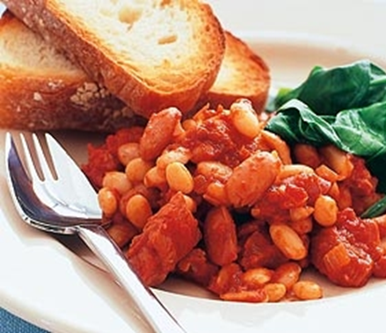
Ingredients
1 Tblsp olive oil
½ onion, finely chopped
1 tsp crushed garlic
400g can cannellini beans, rinsed, drained
400g can diced tomatoes
2 Tblsp molasses
1 Tblsp brown sugar
½ Tblsp Worcestershire sauce
1 tsp Dijon mustard
2 cloves
¼ tsp salt
¼ tsp pepper
Method
- In a saucepan cook onion and garlic over a medium heat until the onion is tender.
- Add beans, tomatoes, molasses, sugar, Worcestershire sauce, Dijon mustard and cloves, stir until well combined.
- Season with salt and pepper. Bring to the boil. Cover and reduce heat to low.
- Simmer, gently stirring every 10 minutes, taking care not to break up beans, until sauce is thick.

