Cornish Pasties

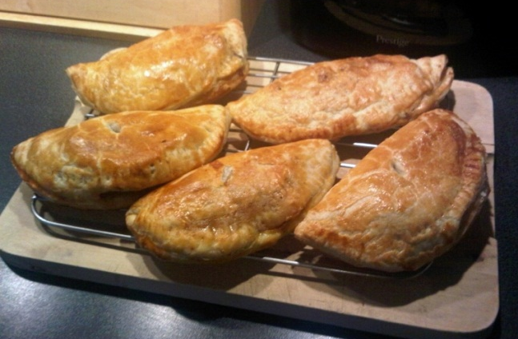
Filling
125g beef mince
½ onion, grated
½ carrot, grated
½ potato, grated
¼ turnip, grated
½ tsp salt
½ tsp pepper
2tsp parsley, finely chopped
2 sheets of puff pastry

- Preheat oven to 200°C.
- In a large bowl combine all the ingredients together.

- Cut 8 circles of pastry from the 2 sheets of puff pastry.

- Divide the meat mixture between the 8 circles of pastry, fold the pastry circles in half over the meat mixture and press down the edges using a fork, making sure they are completely sealed.
- Place on an oven tray and pierce with a fork in 3 places.
- Bake at 200°C for 20 - 25 minutes.

