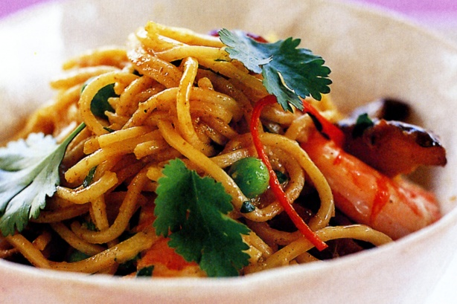
Singapore noodles
220g thin fresh egg noodles
100g chicken, cut in strips
2 Tblsp Kecap manis
1 Tblsp Shaohsing rice wine
½ Tblsp Curry powder
½ tablespoon brown sugar
125ml coconut milk
100ml chicken stock
20ml (1 tablespoon) vegetable oil, plus extra for noodles
1 tsp crushed garlic
2 tsp crushed ginger
½ tsp chili paste
2 spring onions, sliced on the diagonal
½ carrot, cut into thin strips
¼ onion, cut into thin strips
¼ red capsicum, cut into thin strips
50g cooked peeled prawns
30g frozen peas and corn
Fresh coriander leaves, to garnish

- Cook noodles following the packet directions, drain and toss in a little oil.
- Combine the soy, rice wine, curry powder, sugar, coconut milk and stock in a bowl. Set aside.
- Heat oil in a wok over medium-high heat, add the garlic, ginger, chilli, and chicken and fry until the chicken is nearly cooked.
- Add noodles, prawns and carrot, peas and corn, capsicum, onion and spring onion and cook for 2 minutes. Add liquid ingredients and cook for 5 minutes or until most of the liquid has been absorbed.
- Serve garnished with coriander.

