Pumpkin, Chicken and Ricotta Cannelloni

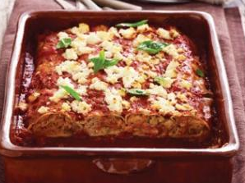
100g pumpkin, peeled and grated
⅛ onion, finely diced
¼ zucchini, grated
¼ carrot, grated
50g chicken mince
50g ricotta
salt and pepper
2 cannelloni sheets
100g tomato pasta sauce
30g grated cheese

- Preheat your oven to 180°c.
- In a large bowl mix the onion, grated vegetables, chicken mince and ricotta until well combined.
- Divide the chicken and vegetable mixture between the 2 cannelloni sheets, and roll them up.
- Spray a small baking dish with oil.
- Put a tablespoonful of the pasta sauce in the bottom of the baking dish, place cannelloni on top.
- Cover with the remaining pasta sauce, and sprinkle with grated cheese.
- Bake for 25 minutes until cheese is golden brown.

