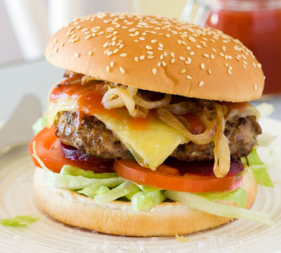
Beef Burgers serves 1
Ingredients
100g beef mince
1 tsp Worcestershire sauce
1 tsp tomato sauce
½ tsp Dijon mustard
1 Tblsp parsley, finely chopped
¼ small carrot, grated
¼ tsp salt
½ slice of bread, crumbed
½ Tblsp milk
1 small onion, thinly sliced
1 Tblsp butter
1 burger roll
assorted salad
Method
- In a large bowl thoroughly combine milk, bread, carrot, beef mince, Worcestershire sauce, tomato sauce, mustard and parsley.
- Divide mixture into 1 large patty, the same size as the roll.
- Place on a baking paper lined oven tray and bake on 200°C for 15-20 minutes, or until well browned.
- While patties are in the oven, melt butter in a small frying pan over a medium heat. Add onion and stir occasionally until golden.

To assemble:
- Place the bases of your burger rolls onto a serving plate and spread with sauce. Top with burger, onion and salad, then finally the top of your burger bun, and serve.

Seasoned Baked Potato Wedges (serves 1)

INGREDIENTS
- 1 large potato
- 1 Tbsp oil

SEASONING
- 1/2 tsp paprika
- 1/4 tsp garlic powder
- 1/8 tsp onion powder (or sub with more garlic powder)
- 1/4 tsp salt
- 1/8 tsp pepper

METHOD
- Preheat oven to 200°C Fan Forced
- Mix the Seasoning ingredients.
- Cut the potatoes in half lengthwise, then cut each half into 4 "wedges" (so you get 8 pieces from each potato). If your potato is small/medium, just cut into 6 wedges.
- Place potatoes in a large bowl, drizzle over oil and seasoning. Toss with hands.
- Spread out on tray, ensuring cut side lies flat on the tray.
- Bake for 35 to 45 minutes, turning once, or until dark golden brown and crispy.
- Serve immediately!

