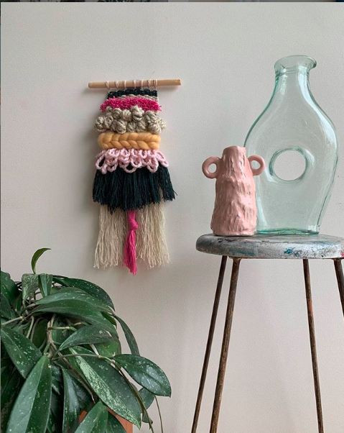
Sustainable Textiles
Weaving
PART 1 – Create an Informative Video/Presentation
Detailing sustainable practices in the textiles industry; considering the following:
- What is sustianability in relation to Fashion and Textiles?
- What problems are associated with the production of textile products and what do manufacturors of textiles do to reduce waste?
- Indentify and discuss 2 factors that need to be considered in relation to the production of textiles to ensure sustainability. Explain. (use less toxic materials, use natural materials)

- Provide examples of sustainable textiles fibres or fibre production methods (use pictures to help illustrate your point)

- Provide 3 examples of a sustainable clothing or textiles item detailing:
What is the product?
Why is this design a sustainable product?

- What does all this mean for us moving forward?

PART 2 – WEAVING TECHNIQUES AND TOOLS (individually)
Include a Diagram/Picture/Sample
for each technique/tool
Include a description of their purpose in relation to creating a woven wall hanging

The Warp (casting on)

The Weft

Beater

Plain Weave

Bubbling

Rya Knots

PART 3 – INSPIRATION BOARD
Your task is to create a sustainable woven wall hanging. Below create an inspiration board to explore possible ideas and consideration, this could include the following :
- Photographs and/or illustrations of inspirational images weaving examples of techniques, colours or textures.
- Physical fibre samples of techniques and fibres you would like to incorporate into your design.
- Any other objects that help convey the mood you are trying to evoke.
- Ideas of how to create a more sustainable design

PART 4 – WEAVING DESIGN

Below create a detailed labelled diagram of your weaving design including: your colour choices, wool thickness/type and any specific techniques, how this design is sustainable.

ASSESSMENT CRITERIA
 | WA | AE | E | BE | WB
Technologies for Society | comprehensive explanation of how people working in design and technologies occupations consider:  - factors that impact on design decisions  - the technologies used to produce products, services and environments | detailed explanation of how people working in design and technologies occupations consider:  - factors that impact on design decisions  - the technologies used to produce products, services and environments | explanation of how people working in design and technologies occupations consider:  - factors that impact on design decisions  - the technologies used to produce products, services and environments | description of how people working in design and technologies occupations consider:  - factors that impact on design decisions  - the technologies used to produce products, services and environments | statements about how people working in design and technologies occupations consider:  - design decisions  - the technologies used to produce products, services and environments
Evalaution of Techniques and Tools | discerning evaluation of techniques and tools and their appropriateness for purpose of producing a woven wall hanging. | informed evaluation techniques and tools and their appropriateness for the purpose of producing a woven wall hanging. | Evaluation of techniques and tools and their appropriateness for the purpose of producing a woven wall hanging. | statements of the techniques and tools and their appropriateness for the purpose of producing a woven wall hanging. | limited statements about the techniques and tools and their appropriateness for the purpose of producing a woven wall hanging.
Design | creation of a sophisticated design based on their evaluation of needs or opportunities | creation of a effective design based on their evaluation of needs or opportunities | creation of a satisfactory design based on their evaluation of needs or opportunities | creation of a design somewhat based on their evaluation of needs or opportunities | Limited creation of a design.
Product | proficient production of high quality designed solutions suitable for the intended purpose by selecting and using appropriate technologies skilfully and safely | effective production of high quality designed solutions suitable for the intended purpose by selecting and using appropriate technologies skilfully and safely | production of high quality designed solutions suitable for the intended purpose by selecting and using appropriate technologies skilfully and safely | guided production of designed solutions for the intended purpose by selecting and using technologies safely | guided production of designed solutions for a purpose by using technologies safely

