Name:________________________________________

Product Design
Fashion Folio

Task: To create a garment suitable for a teenager to wear. You are required to choose from a skirt, shorts, jumper, jumpsuit or dress. The garment chosen must be suitable for your skill level and be made out of fabric that is suitable for the garment chosen.

Design Brief (250 words plus)
You will need to develop a design brief detailing the specifications of your practical product. (ie what needs to be considered for the project to be successful) This will provide you a list of criteria which you will you will use to ensure your products success.

Your design brief will describe:
- What the product has to do?
- What the product should look like?
- What budget do you have?
- What are some constraints, things that you have to do?
- What materials should it be made from?
- What tools are required? Do these need to be learnt?
- What techniques are required? Do these need to be learnt

Inspiration Board
For those who don't already know, an inspiration board (sometimes referred to as a mood board or an idea board) is a collage of images meant to kick-start your imagination.
Your board must include pictures, information, materials and relevant.
Use the following mood board breakdown as a guide:

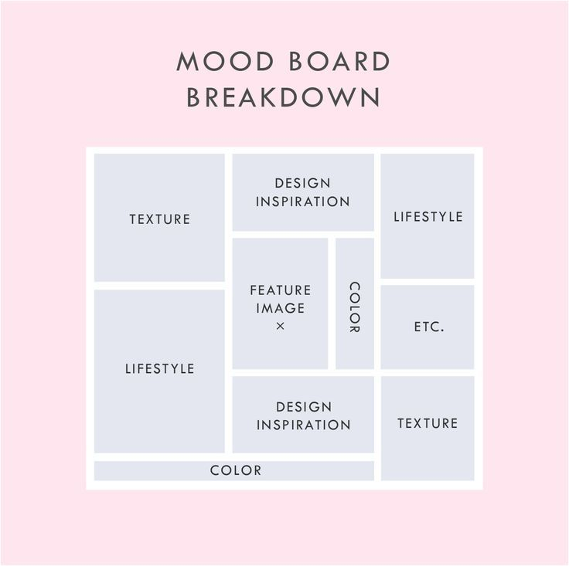

Design
Based on your inspiration board sketch and label your final design idea including the following details:
- What garment was chosen
- What specific details or features will be included
- What sewing techniques will be required and where (ie hem, seam etc)
- What colours
- Any other necessary details

Justification of Design (200 words)
Justify why you have chosen this garment this using this particular design, use the following questions to help guide your explanation:
+ Why have you decided to make this type of garment? Reasons could included:
- Look
- Purpose
- Techniques used/ skill level
- Budget
- Colours

Product Management Plan
Use technology to document your planning and production process using the following format (or similar):

Day/Week | Steps | Image | Production journal of improvements, tips, or changes made
Monday  Week 1 | - Identify the sizing needed for the shorts by looking at a commercial pattern and measuring the hip measurements.  - Trace around the sized need using trace and toil to create a pattern |  | Pinning the trace and toil to the pattern would have helped to keep the pattern steady while tracing to ensure a more accurate pattern for the shorts.
Monday
Week 2

Evaluation (400 words)
Use the following questions to guide your evaluation of the assignment:

- Did your chosen garment meet the criteria that you identified in your design brief, Why/Why not?
- How does your garment compare to a commercially produced equivalent?
- What did your do well in the practical and why?
- What didn’t go so well for you in the practical and why?
- Was your project plan sufficient? Were you able to follow your steps easily or did you have difficulty following them? Explain.
- What techniques did you learn, and how did they effect your product?
- If you were to make this garment again what changes would you recommend and why?

Assessment Rubric – Product Design

 | WA | AE | E | BE | WB
Design Brief | establishment of comprehensive and detailed criteria for success | establishment of informed and detailed criteria for success | establishment of detailed criteria for success | establishment of criteria for success | statements about criteria for success
Design and Justification | - purposeful creation and connection of design ideas and processes of increasing complexity  - discerning justification of decisions | - effective creation and connection of design ideas and processes of increasing complexity  - informed justification of decisions | - creation and connection of design ideas and processes of increasing complexity  - justification of decisions | - partial creation and connection of design ideas and processes  - explanation of decisions | - fragmented creation of design ideas and processes  - statement of decisions
Techniques | discerning evaluation of the features of technologies and their appropriateness for purpose when producing designed solutions for identified needs or opportunities | informed evaluation of the features of technologies and their appropriateness for purpose when producing designed solutions for identified needs or opportunities | evaluation of the features of technologies and their appropriateness for purpose when producing designed solutions for identified needs or opportunities | explanation of the features of technologies and their appropriateness for purpose when producing designed solutions for identified needs or opportunities | statements about the features of technologies when producing designed solutions for identified needs or opportunities
Organisation and Communication of Folio | comprehensive and effective communication and documentation of project | effective communication and documentation of project | communication and documentation of project | partial communication and documentation of project | fragmented communication and documentation of project
Production Plan | application of sequenced production and management plans when producing designed solutions:  - making discerning adjustments to plans when necessary  - working independently and collaboratively | application of sequenced production and management plans when producing designed solutions:  - making informed adjustments to plans when necessary  - working independently and collaboratively | application of sequenced production and management plans when producing designed solutions:  - making adjustments to plans when necessary  - working independently and collaboratively | use of production and management plans when producing designed solutions:  - making adjustments to plans  - working collaboratively | use of plans when producing designed solutions
Final Product | proficient production of high quality designed solutions suitable for the intended purpose by selecting and using appropriate technologies skilfully and safely | effective production of high quality designed solutions suitable for the intended purpose by selecting and using appropriate technologies skilfully and safely | production of high quality designed solutions suitable for the intended purpose by selecting and using appropriate technologies skilfully and safely | guided production of designed solutions for the intended purpose by selecting and using technologies safely | guided production of designed solutions for a purpose by using technologies safely
Evaluation | use of detailed criteria for success to make a discerning evaluation of:  - their ideas  - designed solutions  - processes | use of detailed criteria for success to make an informed evaluation of:  - their ideas  - designed solutions  - processes | use of detailed criteria for success to make an evaluation of:  - their ideas  - designed solutions  - processes | use of detailed criteria for success to make a partial evaluation of:  - their ideas  - designed solutions  - processes | use of detailed criteria for success to make a fragmented evaluation of:  - their ideas  - designed solutions  - processes

