Name:________________________________________

9 Textiles Technology

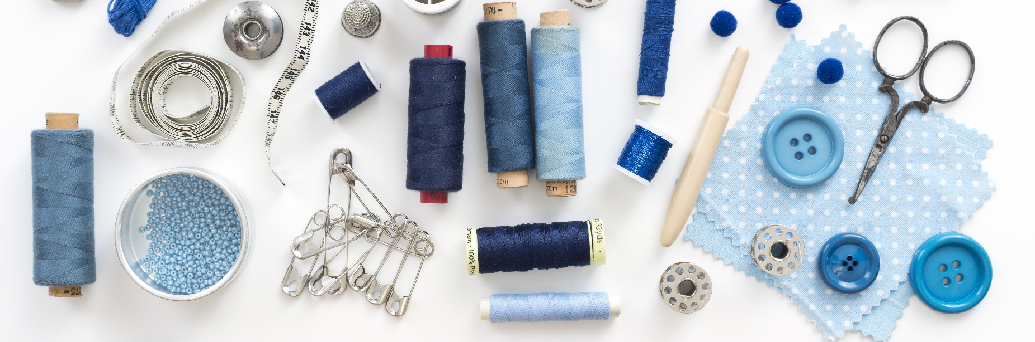

**Safety Rules**

Why do we avoid doing the following when in the textiles classroom, explain in detail:

|  |  |
| --- | --- |
| Action | Explanation |
| 1. Walking around the room with scissors pointing outwards. |  |
| 1. Working at a machine while talking or listening to others talking. |  |
| 1. Running around the room. |  |
| 1. Using an ‘unpick’ incorrectly. Eg. Sharp point facing the body. |  |
| 1. Two or more people at the one machine. |  |
| 1. Not putting the chairs neatly under the desk when they are not in use. |  |
| 1. Leaving pins on the table or the chairs. |  |
| 1. Leaving the iron on when it is not in use. |  |
| 1. Leaving the iron standing on the ironing board. |  |
| 1. Not setting the ironing board up securely. |  |

**Turning Corners**

To sew straight lines and turn corners;

* Begin by sewing at start, sew along straight.
* Slow down as you approach the corner, using the hand wheel to make the last few stitches.
* Stop at the corner, making sure the needle is still in the paper.
* Raise the presser foot and turn the paper until the middle of the presser foot lines up with the line you want to sew on, begin sewing again.
* Repeat this process for each corner.

**Start**

**Extension**

Practice sewing these shapes and lines with thread. 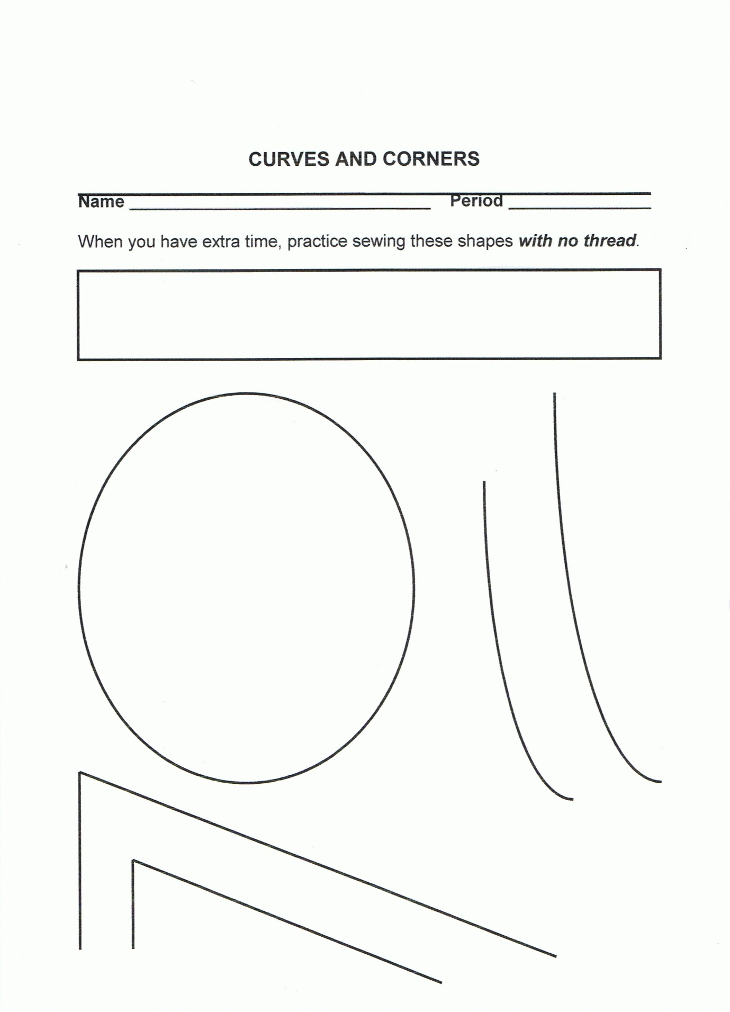

**Overlocked Seam Finishes**

Seams can be either overlocked open or overlocked together, depending on what it is being used for.

Complete a sample of each type, using a 1.5cm seam allowance.

**Closed Seam:**

What is a closed seam?

Source:

Therefore it would be best to use a closed seam for this part of my shorts:

**Attach Sample Here**

**Open Seam:**What is an open seam?

Source:

Therefore it would be best to use an open seam for this part of my shorts:

**Attach Sample Here**

**Hem:**

What is a hem?

Source:

Therefore it would be best to use a hem for this part of my shorts:

**Attach Sample Here**

**Design Brief**

This semester you will design and create a pair of pyjama shorts or pants using the pattern provided. You will **select and buy woven fabric (ie cotton)** to make the shorts or pants (keep a copy of your receipt for your assignment). The shorts or pants must also be suitable for a teenager to wear and they must include an elastic waistband (provided).   
  
They must be completed by the Week 6 Term 3.

**Constraints (What can’t I change?):**

**Consideration (What do I need to think about or investigate?):**

**Mood Board**

Create a Mood Board to communicate your design ideas for your shorts.

**Design Ideas**Sketch and label your final design idea including the following details:  
-elastic  
-pockets only if chosen  
-where a hem, open seam and closed seam are used  
-any other necessary details

Design Idea

I have made this decision because…

**Costing**

|  |  |  |
| --- | --- | --- |
| Item | Amount | Cost |
|  |  |  |
|  |  |  |
|  |  |  |
|  | TOTAL |  |

Attach copy of receipt

**Product Management Plan**Use technology to document your production plan using the following format:

|  |  |  |  |
| --- | --- | --- | --- |
| **Day/Week** | **Steps** | **Image** | **Production journal of improvements and tips** |
| **Monday Week 11** | 1. Identify the sizing needed for the shorts by looking at a commercial pattern and measuring the hip measurements. 2. Trace around the sized need using trace and toil to create a pattern |  | Pinning the trace and toil to the pattern would have helped to keep the pattern steady while tracing to ensure a more accurate pattern for the shorts. |
| **Monday  Week 1** |  |  |  |
|  |  |  |  |
|  |  |  |  |
|  |  |  |  |
|  |  |  |  |
|  |  |  |  |

**Evaluation**

Evaluate your work process and the quality of the construction techniques you have used by answering the following questions:

Describe your task:

......................................................................................................................................................................................................................................................................................................................................................................................................................................................................................................

How did you use your class time effectively?

..............................................................................................................................................................................................................................................................................................................................................................................................................................................................................................................................................................................................................................................................................................................................................................................................................................................................................................................................................................................................................................................................................................................................................................................

How effectively did you construct your shorts? (give a specific example of this)

..............................................................................................................................................................................................................................................................................................................................................................................................................................................................................................................................................................................................................................................................................................................................................................................................................................................................................................................................................................................................................................................................................................................................................................................

What problems did you have throughout the process and how did you overcome them?

..............................................................................................................................................................................................................................................................................................................................................................................................................................................................................................................................................................................................................................................................................................................................................................................................................................................................................................................................................................................................................................................................................................................................................................................

How have your sewing skills developed while creating your shorts? What new techniques and skills have you learnt and what were they used for?

................................................................................................................................................................................................................................................................................................................................................................................................................................................................................................................................................................................................................................................................................................................................................................................................................................................................................................................................................................................................................................................................................................................................................................................................................................................................................................................................................

Did your shorts turn out how you originally imagined? Why/why not?

..........................................................................................................................................................................................................................................................................................................................................................................................................................................................................................................................................................................................................................................................................................................................................................................................................................................

What would you change or improve about the design of your shorts if you did the task again?

..............................................................................................................................................................................................................................................................................................................................................................................................................................................................................................................................................................................................................................................................................................................................................................................................................................................................................................................................................................................................................................................................................................................................................................................

**Self-assessment:**

On a scale of poor – excellent how well would you rate yourself on the following:

**Constructive use of lesson time:**

Poor Satisfactory Good Excellent

**Straight machine stitching:**

Poor Satisfactory Good Excellent

**Neat appropriate sized seams:**

Poor Satisfactory Good Excellent

**Effectiveness of design:**

Poor Satisfactory Good Excellent

**Overall final product neatness:**

Poor Satisfactory Good Excellent

**Assessment Criteria**

|  |  |  |  |  |
| --- | --- | --- | --- | --- |
|  | **WA** | **AE** | **E** | **BE** |
| Critique needs or opportunities to develop design briefs and investigate and select an increasingly sophisticated range of materials, systems, components, tools and equipment to develop design ideas (ACTDEP048) | | | | |
| Techniques and considerations | Creation of designed solutions based on a discerning critical evaluation of needs or opportunities | creation of designed solutions based on an informed critical evaluation of needs or opportunities | creation of designed solutions based on a critical evaluation of needs or opportunities | creation of partial designed solutions based on a partial evaluation of needs or opportunities |
| Develop, modify and communicate design ideas by applying design thinking, creativity, innovation and enterprise skills of increasing sophistication (ACTDEP049) | | | | |
| Generating and designing | Comprehensive and effective communication to different audiences:   * appropriate technical terms   a range of technologies and graphical representation techniques | Effective communication to different audiences:   * appropriate technical terms   a range of technologies and graphical representation techniques | Communication to different audiences using:   * appropriate technical terms   a range of technologies and graphical representation techniques | Partial communication to audiences using:   * technical terms   technologies and graphical representation techniques |
| Develop project plans using digital technologies to plan and manage projects individually and collaboratively taking into consideration time, cost, risk and production processes (ACTDEP052) | | | | |
| Project Planning | Application of sequenced production and management plans when producing designed solutions:   * making discerning adjustments to plans when necessary   working independently | Application of sequenced production and management plans when producing designed solutions:   * making informed adjustments to plans when necessary   working independently | Application of sequenced production and management plans when producing designed solutions:   * making adjustments to plans when necessary   working independently | Use of production and management plans when producing designed solutions:   * making adjustments to plans   working collaboratively |
| Work flexibly to effectively and safely test, select, justify and use appropriate technologies and processes to make designed solutions (ACTDEP050) | | | | |
| Producing and Implementing | Proficient and consistent production of effective designed solutions for the intended purpose independently and safely | Consistent production of effective designed solutions for the intended purpose independently and safely | Production of effective designed solutions for the intended purpose independently and safely | Guided production of designed solutions for the intended purpose safely |
| Evaluate design ideas, processes and solutions against comprehensive criteria for success recognising the need for sustainability (ACTDEP051) | | | | |
| Evaluation | Discerning use of developed criteria for success to judge the suitability of:   * their ideas * designed solutions and processes | Informed use developed of criteria for success to judge the suitability of:   * their ideas * designed solutions and processes | Use of developed criteria for success to judge the suitability of:   * their ideas * designed solutions and processes | Partial use of developed criteria for success to describe the suitability of:   * their ideas * designed solutions and processes |