Pumpkin Curry Created by Sunil Ranasinghe Cuisine: **Sri Lankan** Serves 2

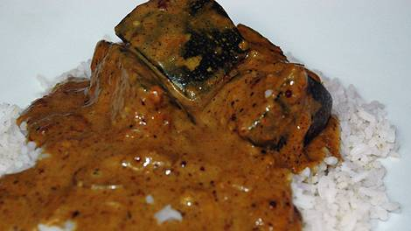http://www.sbs.com.au/food/web/images/hr/hr-left-right.jpgIngredients

200g Chicken, 2cm diced  
http://www.sbs.com.au/food/web/images/hr/hr-left-right.jpg150g pumpkin  
1½ teaspoons curry powder  
½ onion, diced  
1 small chilli, finely sliced  
1 teaspoon minced garlic  
½ tsp wholegrain mustard  
⅛ teaspoon chilli powder  
¼ teaspoon turmeric powder  
¼ teaspoon mustard seeds  
¼ teaspoon ground mustard  
400ml can coconut milk  
½ teaspoon salt  
  
2 teaspoons vegetable oil

Preparation

Wash and cut pumpkin into 2cm cubes.  
  
In a large saucepan heat oil and fry the onions, chicken, pumpkin, garlic, chillies and mustard seeds.   
  
In a small bowl, mix all the other ingredients and add to the saucepan. Continue to cook over a medium heat until the pumpkin is tender.

Serve with rice.

**Microwave Rice**

1 cup of rice

2 cups water

Mix the water and the rice in a microwave safe container in the ratio of 2:1 water: rice (2 cups of water for every cup of rice).

Cover with cling wrap twice, poke 3 holes in it to let out steam.

Put in the microwave and cook on high for 16 minutes.

Once done let the rice sit for about 3-5 minutes so that it finishes cooking then fluff it and serve.

http://www.sbs.com.au/food/web/images/hr/hr-left-right.jpg