**Southern Fried Chicken** Created by Ashley Sheridan Cuisine:**USA** Serves 4

http://www.sbs.com.au/food/web/images/hr/hr-left-right.jpg

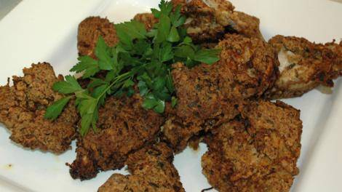Ingredients  
200g chicken fillet, cut into strips  
200ml buttermilk  
½ cup of plain flour   
2 tsp Creole seasoning  
2 tsp onion powder  
2 tsp dried tarragon  
2 tsp dried dill  
1 tsp garlic powder  
1 egg  
Vegetable oil for frying

http://www.sbs.com.au/food/web/images/hr/hr-left-right.jpgPreparation

Soak chicken in buttermilk overnight. This helps to retain the moisture of the chicken.

In a bowl, combine the flour, Creole seasoning, onion powder, tarragon, dill, garlic.

In a small bowl beat the egg.

Remove the chicken from the buttermilk and drain.

Then dip each chicken piece in egg and coat evenly in the flour mixture.

As each piece of chicken is coated place on a plate and continue to coat the remaining chicken.

Heat the oil in a frying pan over a medium heat.

Once the oil is hot add the chicken to the pan and shallow fry for approx. 5 minutes each side or until the chicken is golden brown.

As each piece is cooked, transfer to a paper towel lined plate to drain.  
  
Serve with grits and Southern greens (see other Food Safari USA recipes).

http://www.sbs.com.au/food/web/images/hr/hr-left-right.jpg