Plum Jam Biscuits Created by Mira Valcich Cuisine: **Croatian**

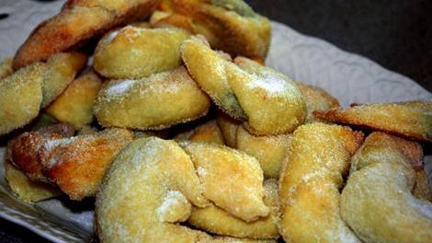http://www.sbs.com.au/food/web/images/hr/hr-left-right.jpgIngredients

125g butter, softened   
150ml cream   
2 tbsp caster sugar   
1tsp vanilla essence  
1¾ cups plain flour   
¾ tsp baking powder   
Plum jam

Caster sugar for coating

http://www.sbs.com.au/food/web/images/hr/hr-left-right.jpg

Preparation

In a large bowl mix the butter, cream, sugar, vanilla and baking powder.   
  
Slowly add the flour to make a soft, stretchy dough.   
  
Roll dough out thinly (approx. 3mm thick) and cut into 15cm wide strips and then into 10cm triangles with a pizza cutter or sharp knife.   
  
Place one teaspoon of jam at the wide end of the triangles and roll each one forward into a U shape.   
  
Bake at 200°C for 10-15 until golden.

http://www.sbs.com.au/food/web/images/hr/hr-left-right.jpgRoll in caster sugar while still warm.