**Lasagne** serves 2

**Ingredients**

*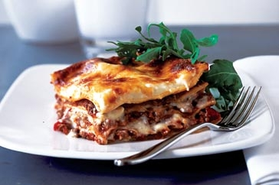Cheese Sauce*25g butter  
25g plain flour  
200ml milk   
70g cheese  
*Pasta Sauce*250g beef mince¼ onion, diced¼ capsicum1 mushroom⅛ tsp oregano¼ tsp minced garlic1 Tblsp sugar400g tinned crushed tomatoes1 Tblsp instant gravy mix to thicken

2 large fresh pasta sheets (Latina Fresh)  
30g extra

1. In a large saucepan fry onion, garlic, capsicum, mushroom and beef mince, until the mince is cooked and there is no moisture in the bottom of the pan.
2. Add the tomatoes and the spices and bring to the boil.
3. Thicken with instant gravy mix.

To assemble the lasagne

1. Preheat the oven to 180°C.
2. In a small foil tray place a small amount of sauce in the bottom.
3. Next place a layer of lasagne pasta on top of the sauce.
4. Spread the lasagne pasta with cheese sauce and top with a layer of pasta sauce.
5. Continue this process until all the pasta sheets have been used.
6. Finishing with a layer of pasta covered in cheese sauce.
7. Sprinkle with the grated cheese.
8. Bake for 20-25 minutes or until the cheese is golden.