Fattoush Created by Sharon Salloum Cuisine: **Syrian** Serves 2

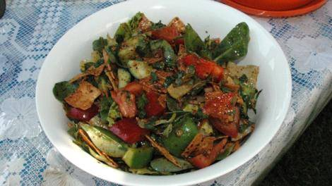http://www.sbs.com.au/food/web/images/hr/hr-left-right.jpgIngredients

**Dressing**  
¼ teaspoon minced garlic  
⅛ teaspoon salt  
¼ teaspoon sweet paprika  
¼ teaspoon lemon pepper  
2 tsp olive oil  
2 tsp lemon juice

**Salad**  
¼ of a pita bread  
½ Lebanese cucumber, cut into 1cm slices  
½ tomato, cut into eight  
1 radishes, halved and thinly sliced  
⅛ red capsicum, cut into 2cm cubes  
⅛ green capsicum, cut into 2cm cubes  
1 iceberg lettuce leaf, roughly torn  
small handful of baby spinach leaves  
⅛ cup roughly chopped mint  
⅛ cup roughly chopped flat-leaf parsley  
1 spring onion, finely sliced

**http://www.sbs.com.au/food/web/images/hr/hr-left-right.jpg**Preparation

**Dressing**  
In a small bowl mix the minced garlic, salt, paprika, lemon pepper, olive oil and lemon juice.

**Salad**  
In a large mixing bowl add the following;   
cucumbers, tomato, baby spinach leaves, radish, lettuce, the red and green capsicum, fresh herbs and the spring onions.

Add the bread, torn into small, rough pieces.

Pour the dressing over the salad and toss well.

Serve.

**http://www.sbs.com.au/food/web/images/hr/hr-left-right.jpg**