Basbousa Created by Amira Georgy Cuisine: **Egyptian**

http://www.sbs.com.au/food/web/images/hr/hr-left-right.jpg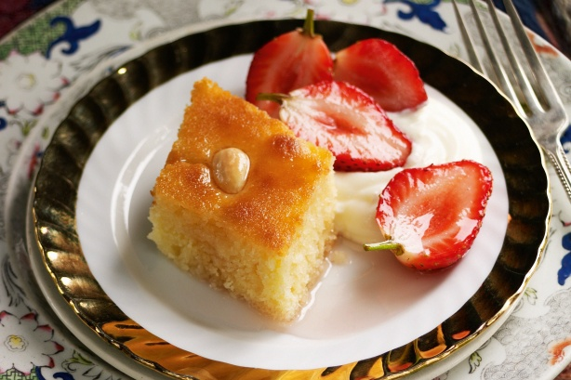Ingredients

1¼ cups coarse semolina  
½ cup desiccated coconut  
½ cup caster sugar  
¼ cup self-raising flour  
100g thick greek yoghurt  
100g unsalted butter, melted  
½ tsp vanilla extract  
approx 12 blanched almonds   
Milk if needed

**Syrup**   
¾ cup caster sugar  
½ cup water  
½ tsp lemon juice  
½ tsp rosewater

http://www.sbs.com.au/food/web/images/hr/hr-left-right.jpgPreparation

Mix the semolina, coconut, sugar, flour, yoghurt, melted butter and vanilla in a bowl. If the mixture is too thick, add a little milk.

Spread into a greased 20cm round cake tin and cut into diamond shapes.

Place one blanched almond in the center of each diamond.

Bake in an oven at 190°C for 25-30 minutes, until golden brown.   
  
**Syrup**  
In a small saucepan stir the sugar and water until the sugar dissolves and simmer for 5 minutes. Stir in the lemon juice and rosewater. Remove from the heat and leave to cool.  
  
Pour the syrup over the cake while the cake is still hot and let it stand until it reaches room temperature.

http://www.sbs.com.au/food/web/images/hr/hr-left-right.jpgServe.