**Brioche French Toast   
with an Apple Compote and Crème Patissiere**

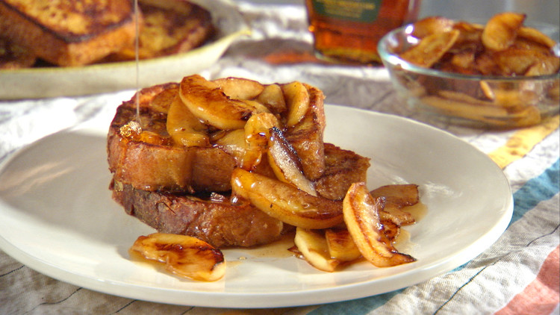**French Toast**

1/2 teaspoon ground cinnamon  
1/8 teaspoon ground nutmeg  
1 tablespoons sugar  
2 tablespoons butter  
2 eggs  
1/8 cup milk  
1/4 teaspoon vanilla extract  
4 slices challah, brioche  
1/4 cup maple syrup, warmed

**Apple Compote**

2 apples, peeled and diced  
1/2 teaspoon cinnamon  
1 tablespoons butter  
1 tablespoons brown sugar

**Crème Patissiere**

1 cup milk  
3 tablespoon caster sugar  
1 Tablespoon cornflour  
½ Tablespoon Vanilla paste  
2 egg yolks

**METHOD:**

**Apple Compote**

1. In a small bowl add diced apples. Pour in cinnamon and stir. Set aside.
2. On medium heat, using a medium size pot melt your butter.
3. Add brown sugar and stir till the sugar has dissolved.
4. Add cinnamon and apples.
5. Let the mixture simmer for 15 minutes or until apples are soft.
6. Take off heat, and allow to cool slightly before serving

**Crème Patissiere**1. Add the vanilla and milk into a saucepan. Heat the milk over medium high heat and bring it to a simmer, almost to a boil.

2. While the milk is being heated, place the sugar, egg and yolks, cornflour and salt in a bowl. Whisk until you have a thick, smooth mix. Set aside until the milk comes to a boil.

3. As soon as the milk starts to bubble, remove it from the heat. Slowly pour about a half of the hot milk in a thin stream, into the egg mix, WHILE WHISKING CONSTANTLY, add the egg mix back into the hot milk in the saucepan.

4. Heat the custard base, over medium heat, while whisking vigorously until it starts to thicken. Take off heat and pass through a sieve and a serve.

**French Toast**

1. In a small bowl, combine cinnamon, nutmeg, and sugar and set aside briefly.

2. In a shallow container whisk together cinnamon mixture, eggs, milk, and vanilla.

3. In large frying pan, melt butter over medium heat.

4. Dip bread in egg mixture. Fry slices until golden brown, then flip to cook the other side.

5. Serve with syrup, Apple Compote and custard