**Fajita Chicken Burrito Bowl Serves 2** Fajita Chicken Burrito Bowl is packed with juicy golden chicken, cilantro lime rice, avocado and a delicious dressing!

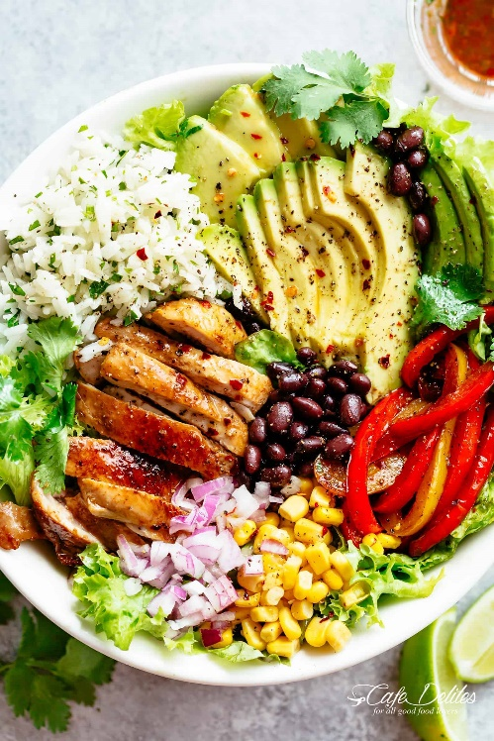**Ingredients**

**For The Chicken And Peppers:**1 tablespoons fresh squeezed lime juice½ tablespoon oil½ teaspoon garlic, minced¼ teaspoon ground chili (adjust to your desired spice   
preference)½ teaspoon each ground cumin and salt½ tablespoon fresh chopped coriander, (optional)1 large chicken breast, cut into strips  
1 large capsicum, cut into strips

**For The Rice:**¼ cup long grain white rice½ cup chicken stock (or broth)½ teaspoon garlic, minced½ tablespoons lime juice1 tablespoons finely chopped coriander

**For Burrito Bowl:**1 Romaine lettuce leaves washed and strained dry100g black beans, washed and drained1 corn on cob  
¼ red onion, chopped½ avocado peeled, seeded and sliced

**Dressing:**1 tablespoons olive oil1 ½ tablespoons freshly squeezed lime juice½ tablespoon finely chopped cilantro, (or parsley) -- adjust to your taste½ teaspoon garlic, crushed  
¼ teaspoon brown sugar  
1/8 teaspoon ground Cumin  
¼ teaspoon salt  
¼ teaspoon red chili flakes (optional)

* 1 tablespoons olive oil
* 1.5 tablespoons freshly squeezed lime juice
* 0.5 tablespoon finely chopped cilantro, (or parsley) -- adjust to your taste
* 0.5 cloves garlic, crushed
* 0.25 teaspoon brown sugar
* 0.13 teaspoon ground Cumin
* 0.25 teaspoon salt
* 0.25-0.5 teaspoon red chili flakes (optional)
* 1 tablespoons olive oil
* 1.5 tablespoons freshly squeezed lime juice
* 0.5 tablespoon finely chopped cilantro, (or parsley) -- adjust to your taste
* 0.5 cloves garlic, crushed
* 0.25 teaspoon brown sugar
* 0.13 teaspoon ground Cumin
* 0.25 teaspoon salt
* 0.25-0.5 teaspoon red chili flakes (optional)

**Instructions**

**For Chicken:**

1. In a large shallow bowl, combine lime juice, oil, garlic, cumin, salt, chili and coriander; mix together. Add the chicken.
2. Heat a large frying pan on medium-high heat. Add a drizzle of olive oil to lightly coat the bottom of the pan. Sear the chicken on both sides until golden, and cooked right through (about 5 minutes per side, depending on the thickness of your strips). Flip them a couple of times while cooking so they get a nice even char.
3. Transfer chicken to a plate, loosely cover with foil and let rest.
4. Add the capsicum to the pan (drizzle with a little extra oil only if needed), and cook until soft and slightly charred. Season with salt and pepper.

**For Rice:**

* **While the chicken is cooking, cook rice:** Combine together the rice, chicken stock (or broth), and garlic in a pot over high heat. Mix well and bring to a boil. Reduce heat and cover with a lid until the rice is cooked through.
* Fluff up rice with a fork and mix through lime juice and coriander. Season to taste with salt and pepper, if needed.

**Dressing:**

* Whisk dressing ingredients together to combine.

**Assembly:**

* Combine lettuce, beans, corn, onion and capsicum into 2 bowls. Arrange into bowls. Top each with avocado slices and drizzle with dressing.