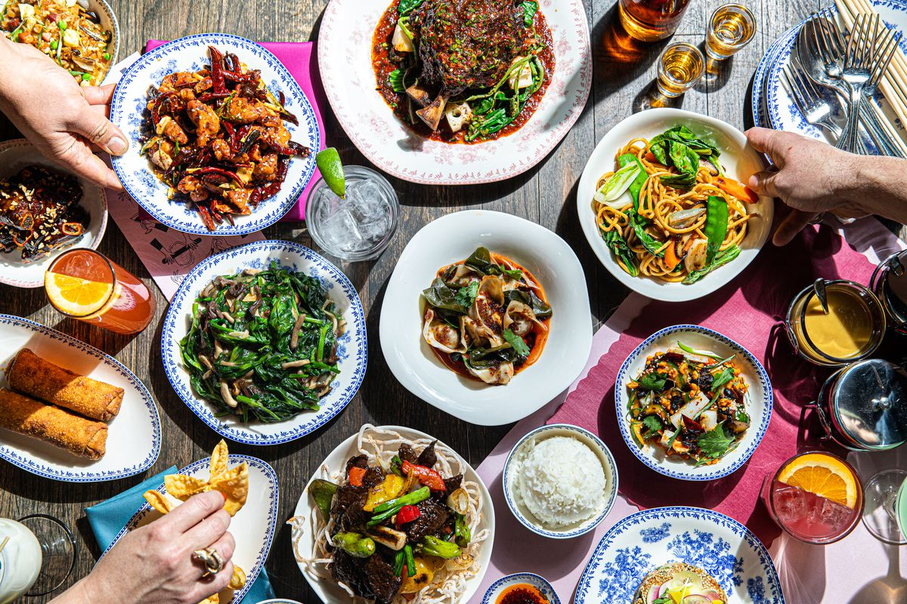 **Restaurant   
menu**

**Design Brief**

You are required to develop a restaurant menu suitable to sell to 13-17 year olds. The food on the menu must consider the audience, be appropriately priced and reflect a specific theme of your choice. You will be required to create, cost and present one dish that is mentioned on the menu.

The product you decide to make will need to be made in a 90 minute lesson and you should attempt to challenge your skill level, whilst working safely with the appropriate tools and equipment.

**1. Criteria for Success**List specific factors that need to be considered to make this task successful in the table below:

|  |  |
| --- | --- |
| **Considerations (flexible factors that allow the product to be changed/modified)** | **Constraints (inflexible factors that must comply to the design brief)** |
|  |  |

Develop a set of CRITERIA FOR EVALUATION from the table. That is, put the criteria into question format to ask yourself when you evaluate the process at the end of the project (ie Did I use my time efficiently during the lesson?)

**2. RESEARCH (500 words)**

**In order to create a restaurant menu it is important to understand menu structure and design. Use the following questions to guide your investigation, make sure you use in-text referencing and a reference list.**

1. What types of information does a menu provide customers?

2. Explain the differences between an a la carte, degustation, buffet and tapas menu.

3. List and explain 5 things that determine what dishes appear on a menu in a hospitality establishment.

4. What other issues do people working in the food industry need to consider creating a restaurant menu? Explain

**3. Generating Ideas**

Using the diagram below, brainstorm possible ideas that could be considered for your restaurant menu.

|  |  |  |  |  |  |  |  |  |
| --- | --- | --- | --- | --- | --- | --- | --- | --- |
|  |  |  |  |  |  |  |  |  |
|  |  |  |  |  |  |  |  |  |
|  |  |  |  |  |  |  |  |  |
|  |  |  |  |  |  |  |  |  |
|  |  |  |  | **Restaurant**  **Menu** | Allergies |  | Allergies |  |
|  |  |  |  |  |  |  |  |  |
|  |  |  |  |  |  |  |  |  |
|  |  |  |  |  |  |  |  |  |
|  |  |  |  |  |  |  |  |  |

**4. Market Research (Survey)**

- Create a survey to ask people within your target audience about what they would prefer on a restaurant menu. Survey questions should reflect what you want to find out based on your research or brainstorming.

- **What did you notice from your observations which will be useful when developing your menu? Explain Why?**

**5. Final Product Design**

Based on your, research, brainstorming and feedback create your final menu design.

**6. Justification (200 words)**

Justify how your final menu and recipe decisions meet the task, you should consider the criteria that you identified in part 1 of this assignment.

**7. Practical**

You are to make your final practical product and present at the end of the double lesson (90minutes)

**Complete a food order, time plan and costing table to be handed up with your recipe 1 week before the practical application.**

**8. Evaluation (500 words)**

Use the following questions to guide your evaluation of the assignment:

* Did your product meet the criteria that you identified in your criteria for success? Why/Why not?
* How does your product compare to a commercially produced equivalent?
* What did your do well in the practical and why?
* What didn’t go so well for you in the practical and why?
* Was your planning sufficient? Were you able to follow your steps easily or did you have difficulty following them? Explain.
* If you were to make this again what changes would you recommend and why?

**Year 9/10 Restaurant Design Criteria**

|  |  |  |  |  |  |  |
| --- | --- | --- | --- | --- | --- | --- |
|  |  | WA | AE | E | BE | WB |
| Technologies and society | Investigation | comprehensive explanation of how people working in design and technologies occupations consider:   * factors that impact on design decisions * the technologies used to produce products, services and environments | detailed explanation of how people working in design and technologies occupations consider:   * factors that impact on design decisions * the technologies used to produce products, services and environments | explanation of how people working in design and technologies occupations consider:   * factors that impact on design decisions * the technologies used to produce products, services and environments | description of how people working in design and technologies occupations consider:   * factors that impact on design decisions * the technologies used to produce products, services and environments | statements about how people working in design and technologies occupations consider:   * design decisions * the technologies used to produce products, services and environments |
| Generating and designing | Designing/Justification | * purposeful creation and connection of design ideas and processes of increasing complexity * discerning justification of decisions | * effective creation and connection of design ideas and processes of increasing complexity * informed justification of decisions | * creation and connection of design ideas and processes of increasing complexity * justification of decisions | * partial creation and connection of design ideas and processes * explanation of decisions | * fragmented creation of design ideas and processes * statement of decisions |
| Documentation of Folio | comprehensive and effective communication and documentation of projects, | effective communication and documentation of projects, | communication and documentation of projects, | partial communication and documentation of projects, | fragmented communication and documentation of projects |
| Producing and implementing | Practical | proficient production of high quality designed solutions suitable for the intended purpose by selecting and using appropriate technologies skilfully and safely | effective production of high quality designed solutions suitable for the intended purpose by selecting and using appropriate technologies skilfully and safely | production of high quality designed solutions suitable for the intended purpose by selecting and using appropriate technologies skilfully and safely | guided production of designed solutions for the intended purpose by selecting and using technologies safely | guided production of designed solutions for a purpose by using technologies safely |
| Evaluating | Criteria for Success | establishment of comprehensive and detailed criteria for success, including sustainability considerations | establishment of informed and detailed criteria for success, including sustainability considerations | establishment of detailed criteria for success, including sustainability considerations | establishment of criteria for success, including sustainability considerations | statements about criteria for success |
| Evaluation | use of detailed criteria for success to make a discerning evaluation of:   * their ideas * designed solutions   processes | use of detailed criteria for success to make an informed evaluation of:   * their ideas * designed solutions   processes | use of detailed criteria for success to make an evaluation of:   * their ideas * designed solutions   processes | use of detailed criteria for success to make a partial evaluation of:   * their ideas * designed solutions   processes | use of detailed criteria for success to make a fragmented evaluation of:   * their ideas * designed solutions   processes |
| Collaborating and managing | Practical Time Plan | application of sequenced production and management plans when producing designed solutions:   * making discerning adjustments to plans when necessary   working independently and collaboratively | application of sequenced production and management plans when producing designed solutions:   * making informed adjustments to plans when necessary   working independently and collaboratively | application of sequenced production and management plans when producing designed solutions:   * making adjustments to plans when necessary   working independently and collaboratively | use of production and management plans when producing designed solutions:   * making adjustments to plans   working collaboratively | use of plans when producing designed solutions |