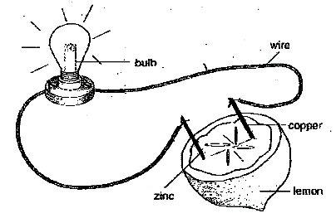
Design Task: Electrochemistry

Introduction and Purpose of Task:
Galvanic cells are electrochemical cells that produce energy.
Two half cells are connected by an external circuit to enable a redox reaction to occur. Galvanic cells are used as portable sources of energy in the form of batteries.
The aim of this task is to design and carry out an investigation to test the effect of one factor on the production of electricity by a galvanic cell.
Part A: Design your own experiment
You will initially work individually to consider which factor would be best to investigate and design an experimental procedure to investigate the effect of this factor on the production of electricity.
- consider how various factors could affect the outcome of the investigation
- write a hypothesis
- identify the dependent variable and the independent variable
- consider factors that should be held constant and explain why and how you will attempt to control these factors
- identify factors that may not be able to be controlled
- prepare a list of materials required
- write a procedure to test the hypothesis
- consider how the data will be displayed and analysed
- identify safety considerations.
Submit your design to your teacher for checking.

Part B: Perform the experiment
The investigation will be conducted in a double lesson.
Students work in pairs but each student should record the results.

Part C: Write an individual investigation report
Use the data you have collected to write your own report. The report should include the following:
Introduction: Include a brief description of the galvanic cell used and the relevant electrochemistry concepts and chemical equations. State the purpose of the investigation and the hypothesis to be tested.
Results: Include an appropriate table and graph.
Discussion: Include analysis of the data and evaluation of the method. Discuss the significance of errors on the results.
Conclusion: a conclusion, with justification, that relates to the data.

Guidelines for addressing the Performance Standards in the report:
Section of the Report | Requirements/Indicators | Performance Standards
Introduction | Relevant chemistry Information presented that relates specifically to the investigation. The information relates to the aim of the experiment. | KA4
Aim | Indicates the purpose of the investigation | IAE1
Hypothesis | Links the independent and dependent variable and is a prediction. | IAE1
Method | Describes how the independent variable is changed, is detailed and describes how the dependent variable is measured.  All variables should be identified.  A clear and logical procedure is outlined with enough detail for someone else to repeat. | IAE1
Safety Considerations | Identify hazards and how they are managed and the precautions taken in the lab. | IAE1  IAE2
Results | Data is represented in an appropriate manner  Table has the correct format  Significant figures are correct  Graphs are drawn appropriately- axis are labelled, appropriate scale used, title, size, correct format | IAE2
Discussion | Explains all the data obtained and any overall trend in the results  Provides reasoning based on the data for supporting or rejecting the hypothesis  Evaluates the experimental method and identifies potential sources of uncertainty, including random and systematic error, and the effect on the results.  Could include a discussion of the data’s reliability, precision, accuracy and validity. | IAE3  IAE4
Conclusion | A justified statement based on the hypothesis that acknowledges the limitations of the conclusion. | IAE3
Communication | Use of appropriate language and chemical terms, equations, representations and conventions | KA4

