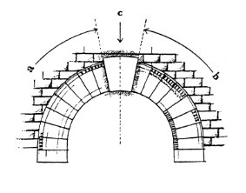

Keystone Species

Stage 1 Biology Folio Task

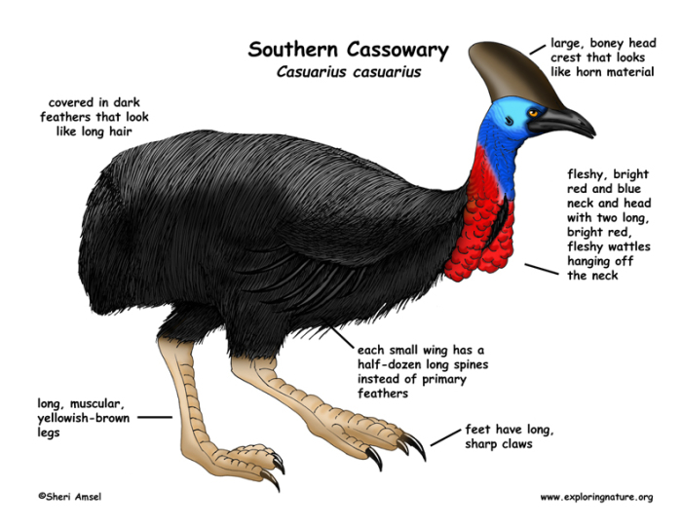

Keystone Species – Human Endeavour Task

Introduction and Purpose of task:
The term keystone species was created by American zoologist Robert T. Paine in 1969. He likened these species to the pillars of a bridge, as without these the bridge would not stand.
A keystone species
- is a species that has a disproportionately large effect on its ecosystem relative to its abundance (population’s size).
- can be described as playing an important role in maintaining the structure the community.
  - Such species help to maintain local biodiversity within a community either by controlling populations of other species that would otherwise dominate the community or by providing critical resources for a wide range of species.

To complete this task you will need to follow the steps outlined.
- Go to the following URL
http://www.australiangeographic.com.au/topics/wildlife/2014/09/australias-keystone-endangered-species
The URL provided, is to guide your search, and is not an extensive list of Australian keystone species. You may choose to investigate other keystone species identified from other sources.
- Choose a keystone species that may be endangered due to human activities.
- Investigate the various effects these activities have on the species and its ecosystem
- Evaluate the potential solutions for reducing the impact of human activities on the species and its ecosystem, AND suggest with good reasoning which may be the most effective.
- Choose at least one of the Science as a Human Endeavour understandings (see Appendix I) and link it to the information you have researched as a focus for your scientific communication.
An example of a possible connection between Science as a Human Endeavour 3: ‘The acceptance and use of scientific knowledge can be influenced by social, economic, cultural, and ethical considerations’ is:

The economic impact of not using a fertiliser for farmers has not been assessed. While it is clear that the fertiliser is likely to be responsible for contamination of water sources, no suitable replacement has yet been developed.
- Prepare a scientific communication, using a format of your choice and the information you have researched, analysed and connected to the Science as a Human Endeavour understanding.

Your report must include the following:

Section | Suggested Details
Introduction | - link to which area(s) of SHE your analysis focuses on  - relevant biology concepts and background info that relate to your report (ecology, biodiversity, human impact, etc)  - brief introduction to your keystone species and the issues
Human Impact | - description of keystone species and the role it plays in the community  - human impacts on your keystone species and the effects (on keystone and rest of ecosystem)  - reasons for human activities that impact  - current status of your species  - scenarios of what could happen if keystone species became extinct  - ethical, cultural, economic, political, social considerations related to your species and the human impact  - REALLY CLEAR links to SHE – bold these references and use SHE language
Solutions | - suggested solutions for how these human activities could be eliminated or better managed to reduce impact on species and its ecosystem (well thought out and researched) – could be a range of suggestions including use of technology, etc.  - REALLY CLEAR links to SHE - bold these references and use SHE language
Conclusion | - suggest with good reasoning which solution is likely to be the most effective and WHY (strongly justify).  - Explicitly address how the SHE has been addressed in your report

Referencing:
You must use in-text referencing and have a completed and alphabetically listed reference list at the end (not included in word count). For example:

Badger, T., 2016, ‘Are Meles meles Really a Keystone Species?’, Natural Review.org, www.thisisatotallyfake.urlbyuncletim.badger/justtoshowyou/howto/dothis.com, Accessed 28 May 2021.

In-text reference for above would be: (Badger, 2016)

Assessment Conditions:
Complete according to timeline below. Class time provided for research and support (negotiated).
Students may submit one draft for feedback (but not after the draft close date).
Word Count: maximum of 1000 words (not including reference list), if written, 6 minutes for an oral presentation (recorded), or equivalent if a multimodal product.

Completion Timeline:
* the following needs to be handed up through Teams

- Keystone species selected Monday May 4th (Wk2)
- *Rough reference list (e-submitted) Monday 18th May (Wk4)
- *Draft close date Monday 25th May (Wk5)
- *Final Report Tuesday 9th June (Wk7) | first exam day

Appendix 1 – SHE Focus Areas
Your research and article/report should have a focus on at least one of the understandings of Science as a Human Endeavour (SHE) listed below:

1. Communication and Collaboration
- Science is a world-wide collaboration that involves international efforts and knowledge sharing to plan, conduct, review and verify scientific findings and efforts

2. Development
- Development of understanding and theories requires lots of different evidence from many areas of science.
- Development of new technology can improve efficiency of doing science (data collection and analysis) and this may help improve understanding and theories.

3. Influence
- Advances in scientific understanding in one field can influence and be influenced by other areas of science, technology, engineering, and mathematics.
- The use and adoption of scientific ideas and findings can be influenced by social, economic, cultural, and ethical considerations.

4. Application and Limitation
- Scientific approaches and findings can help scientists find solutions, make discoveries, develop plans for sustainability, and evaluate economic/social/environmental impacts
- The use of scientific knowledge may have beneficial or unexpected consequences (positive or negative) - this requires monitoring, ongoing assessment, and evaluation of risks
- Science informs public debate and is in turn influenced by public debate

Appendix 2 - Further Reading on Keystone Species:

National Geographic info
https://www.nationalgeographic.org/encyclopedia/keystone-species/

Nature – Knowledge Project
https://www.nature.com/scitable/knowledge/library/keystone-species-15786127

NAME________________________
DATE_____________
Stage 1 Biology
Keystone Species – Human Endeavour Folio Task

 | Criteria Features | A | B | C | D | E
IAE2 | Obtaining, recording, and representing data with conventions and formats | Appropriate; accurate and highly effective | Appropriate; mostly accurate and effective | Generally appropriate, with some errors but generally accurate and effective | Inconsistent, with occasional accuracy and effectiveness | Attempts to record and represent some data, with limited accuracy or effectiveness
IAE3 | Analysis and interpretation of data and evidence | Systematically analyses and interprets | Logically analyses and interprets | Undertakes some analysis and interpretation | Describes data and undertakes some basic interpretation | Attempts to describe results and/or interpret data
 | Formulate and justify conclusions | Logical conclusions with detailed justification | Suitable conclusions with reasonable justification | Generally appropriate conclusions with some justification | Basic conclusion | Attempts to formulate a basic conclusion
KA1 | Knowledge and understanding | Deep and broad knowledge; a range of biological concepts | Some depth and breadth; a range of biological concepts | Present for a general range of biological concepts | Basic and partial | Limited recognition and awareness
KA3 | Exploration and understanding of the interaction between science and society | Critical; good depth | Logical; some depth | Some aspects explored and understood | Partial exploration and understanding of some aspects | Attempts to explore and identify an aspect
KA4 | Communication of knowledge | Highly effective use of appropriate terms, conventions, and representations | Mostly coherent, with effective use of appropriate terms, conventions, and representations | Generally effective, using some appropriate terms, conventions, and representations | Basic; using some appropriate terms, conventions, and/or representations | Attempt is made

