Stage 1 Biology Course Calendar 2022
**Rough Outline – Subject to Change**

Blue topics = Cells & Microorganisms
Green topics = Biodiversity & Ecosystem Dynamics

Week | Topic | Workbook | Information
1-1 | - Living/Non-living things  - Cell Theory  - Prokaryotic vs Eukaryotic Cells | P6-15  P16  P17-25 | REMOTE LEARNING
1-2 | - Organelles [cheek/onion cell mounts]  - Cell Cycle & Mitosis | P26-38 | REMOTE LEARNING
1-3 | - Comparing Mitosis & Binary Fission | P26-38
1-4 | - Energy requirement in cells  - Photosynthesis, Respiration,  - ATP  - Fermentation  - SHE ELEMENTS | P39—47
1-5 | - Fermentation & energy | P39—47 | Fri = Swimming Carnival
1-6 | - Cell Membrane  - SA:V ratio | P48-65 | Fri = Student Free Day
1-7 | - Cell Membrane & Transport | P48-65 | Mon = Holiday
1-8 | - Passive transport methods  (diffusion, osmosis, facilitated diffusion) | P48-65
1-9 | - Active Transport Methods | P48-65 | Fri = 11 Camps
1-10 | 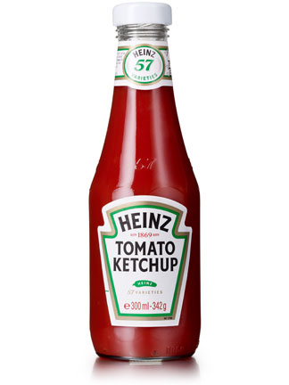  Ketchup Week  - Transcription/Translation |  | Mon = 11 Camps  Thurs = Inter Athletics Day
1-11 | - Importance of biodiversity (genetics, species, ecosystems)  - Keystone Species Intro | P286-287,385  P291-298  P361-364 | Wed = Sports Day  Thurs = Holiday  Fri = Holiday

2-1 | - Abiotic and Biotic factors & relationships (impact on ecosystem)  - Patterns within communities  - Energy flow through ecosystems | P332-339  P288-290  P340-342  P343-346
2-2 | - Populations and ecological niches  - Taxonomy – biologically classification hierarchy | P355-360  P299-318
2-3 | - Reproductive Isolation & adaptations  - Adaptations | P319-321  P322-331
2-4 | - Water and Nutrient cycles | P347-350,352-354 | Wed = Inter Swimming Day
2-5 | - Ecological change – succession  - Human impact on ecosystems  - Destruction of habitat  - Measuring and predicting impact of environmental change | P365-366  P351  P371-384
2-6 | Ketchup Week |  | Fri = Student Free Day
2-7 | 9-11 EXAMS & 7-10 Focus Days  (Tues – Fri) |  | Mon = Holiday

