**Cell Microscopy**

**Stage 1 Biology**

**Science as a Human Endeavour**

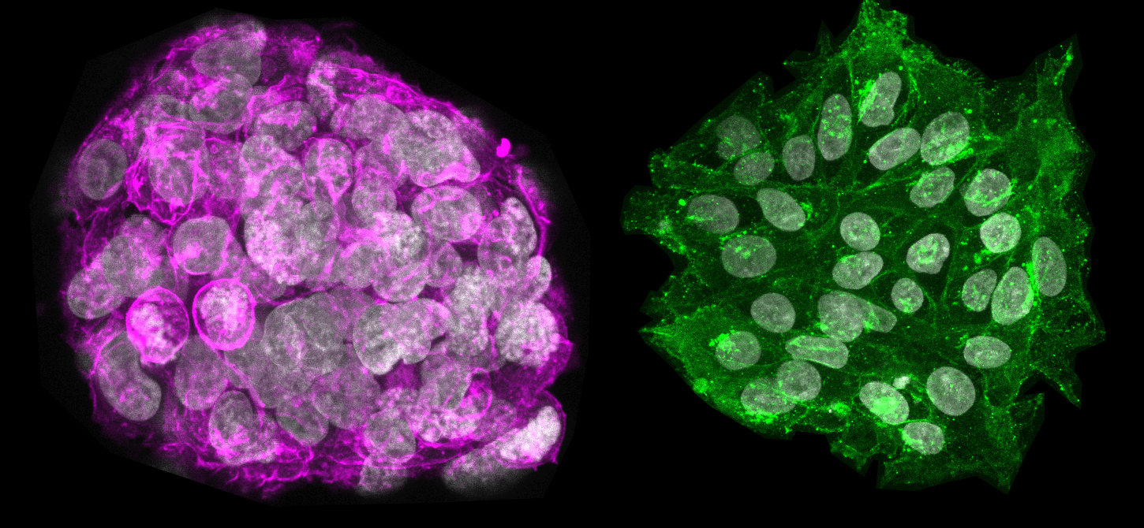

Immunofluorescence microscopy reveals the different protein profiles of immature stem cells (coloured pink) and mature stem cells (coloured green). Credit: Sarita Panula  
  
Read more at: <https://phys.org/news/2017-03-tools-embryonic-stem-cells.html#jCp>

**Cell Microscopy – Human Endeavour Task (FORMATIVE)**

**Introduction and Purpose of task:**

Cell microscopy refers to the viewing of cells using microscopic methods in order to study them in more detail. This field has made great advancements in recent times. Below are links to a number of recent articles that have been published on the current state of cell microscopy.

Your task is to report on the science of microscopy and the recent technologies that have been developed. You will highlight two SHE aspects that relate to this: Communication & Collaboration, and Development.

**Your report must include the following:**

* A brief **introduction** about microscopes and their history of use in Biology.
* An analysis of how technology in microscopy demonstrates aspects of the SHE #1 – **Communication and Collaboration** (see elaboration below)
* An analysis of how technology in microscopy demonstrates aspects of the SHE #2 – **Development** (see elaboration below)
* An explanation and conclusion about the **overall impact** of current technology and its potential for the future – eg. what further developments could be made, impact on quality of life, influence on human activities, possible economic benefits, ability to better address issues for humans, etc.

**Length of Report (guidelines):**

Introduction ≂ 150 words

SHE – Communication & Collaboration: ≂ 200 words

SHE – Development ≂ 200 words

Impact: ≂ 150 words

Total max word length ≂ 700 words

Draft: one draft before final submission (this is formative)

**Getting started – article links:**

Below are four links to articles to get your research started in order to write the sections of your report. You are not limited to these articles – you will need to expand your reading from these. In these articles you will find concepts and ideas and references that may need further research for you to understand or elaborate on.

Microscopy Collaboration Highlight

<https://sdepscor.org/microscopy-collaboration-highlight/>

The microscopic advances that are opening big opportunities in cell biology

<https://www.nature.com/articles/d41586-019-03650-w>

New technology to capture live cell images opening new possibilities to the study of cell biology

<https://phys.org/news/2017-08-technology-capture-cell-images-possibilities.html>

New microscope captures detailed 3-D movies of cells deep within living systems

<https://phys.org/news/2018-04-microscope-captures-d-movies-cells.html>

# Better together: Merged microscope offers unprecedented look at biological processes

## - Researchers combine two microscope technologies to create sharper, faster images

<https://www.sciencedaily.com/releases/2018/05/180507111909.htm?utm_medium=cpc&utm_campaign=ScienceDaily_TMD_1&utm_source=TMD>

# New high-speed 3-D microscope -- SCAPE -- gives deeper view of living things

<https://www.sciencedaily.com/releases/2015/01/150119124520.htm?utm_medium=cpc&utm_campaign=ScienceDaily_TMD_1&utm_source=TMD>

**Referencing:**

You must use proper in text referencing and provide a reference list at the end of your report (not included in word counts). **Keep track of your references as you go. Here is an example from a Stage 2 Biology report:

**Example in text reference:**

“Recent findings show that, “with increasing miniaturization of electric motors and advances in computing power this is becoming less of a challenge” (Stuart, N 2018).”

**Reference list entry for this source:**

Stuart, N. 2018, ‘Future Prosthetics: towards the bionic human’, The Engineer, 4 January 2018, <https://www.theengineer.co.uk/future-prosthetic/>, accessed 24 June 2018.

**Elaborations – SHE Focus Areas**

Your research and article/report should have a focus on the first two understandings of Science as a Human Endeavour (SHE) listed below:

**1. Communication and Collaboration**

* Science is a world-wide collaboration that involves international efforts and knowledge sharing to plan, conduct, review and verify scientific findings and efforts

**2. Development**

* Development of understanding and theories requires lots of different evidence from many areas of science.
* Development of new technology can improve efficiency of doing science (data collection and analysis) and this may help improve understanding and theories.

**3. Influence**

* Advances in scientific understanding in one field can influence and be influenced by other areas of science, technology, engineering, and mathematics.
* The use and adoption of scientific ideas and findings can be influenced by social, economic, cultural, and ethical considerations.

**4. Application and Limitation**

* Scientific approaches and findings can help scientists find solutions, make discoveries, develop plans for sustainability, and evaluate economic/social/environmental impacts
* The use of scientific knowledge may have beneficial or unexpected consequences (positive or negative) - this requires monitoring, ongoing assessment, and evaluation of risks
* Science informs public debate and is in turn influenced by public debate

NAME________________________

DATE_____________

Stage 1 Biology

Cell Microscopy Report

|  |  |  |  |  |  |  |
| --- | --- | --- | --- | --- | --- | --- |
|  | **Criteria Features** | **A** | **B** | **C** | **D** | **E** |
| IAE3 | *Analysis and interpretation of data and evidence* | Systematically analyses and interprets | Logically analyses and interprets | Undertakes some analysis and interpretation | Describes data and undertakes some basic interpretation | Attempts to describe results and/or interpret data |
| *Formulate and justify conclusions* | Logical conclusions with detailed justification | Suitable conclusions with reasonable justification | Generally appropriate conclusions with some justification | Basic conclusion | Attempts to formulate a basic conclusion |
| KA3 | *Exploration and understanding of the interaction between science and society* | Critical; good depth | Logical; some depth | Some aspects explored and understood | Partial exploration and understanding of some aspects | Attempts to explore and identify an aspect |
| KA4 | *Communication of knowledge* | Highly effective use of appropriate terms, conventions, and representations | Mostly coherent, with effective use of appropriate terms, conventions, and representations | Generally effective, using some appropriate terms, conventions, and representations | Basic; using some appropriate terms, conventions, and/or representations | Attempt is made |