Biomagnification of Pesticides
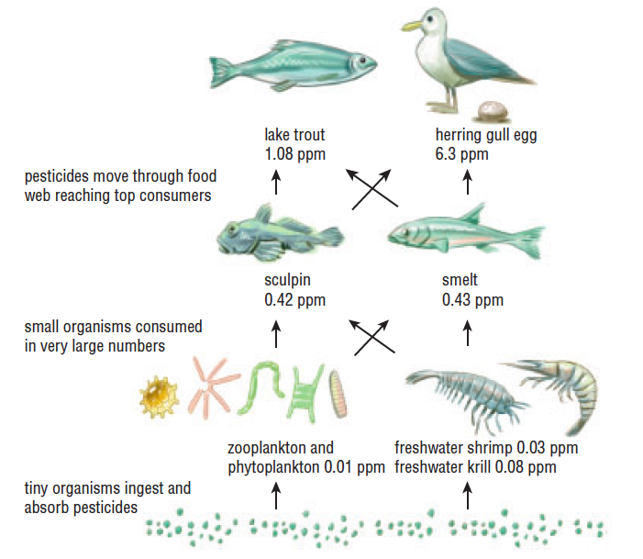

Let’s Put DDT on everything
https://www.youtube.com/watch?v=-UiCSvQvVys

Classic – ad campaign
https://www.youtube.com/watch?v=gtcXXbuR244

Great summary – chop start/end
https://www.youtube.com/watch?v=TZk6vcmLcKw

DDT

Dichlorodiphenyltrichloroethane, commonly known as DDT, is a colorless, tasteless, and almost odorless crystalline chemical compound, an organochlorine. Originally developed as an insecticide, it became infamous for its environmental impacts. DDT was first synthesized in 1874 by the Austrian chemist Othmar Zeidler.

Examples

Plastics BPA
Heavy Metals
PCBs
Selenium

Chlorinated hydrocarbons

Pesticides
Fungacides
Herbicides

