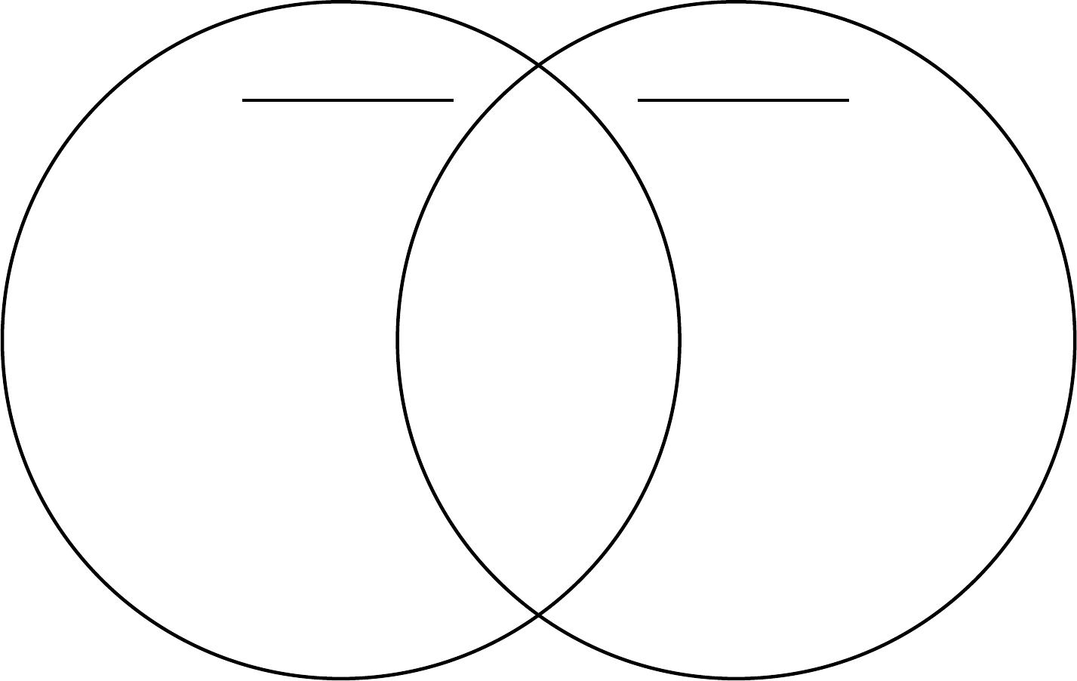

Eukaryotic

Prokaryotic