ATP Energy Worksheet

1. The process of respiration produces energy that is stored in chemical form (chemical energy). Explain what this means.

2. Examine the diagram of a phospholipid bilayer with various proteins in it
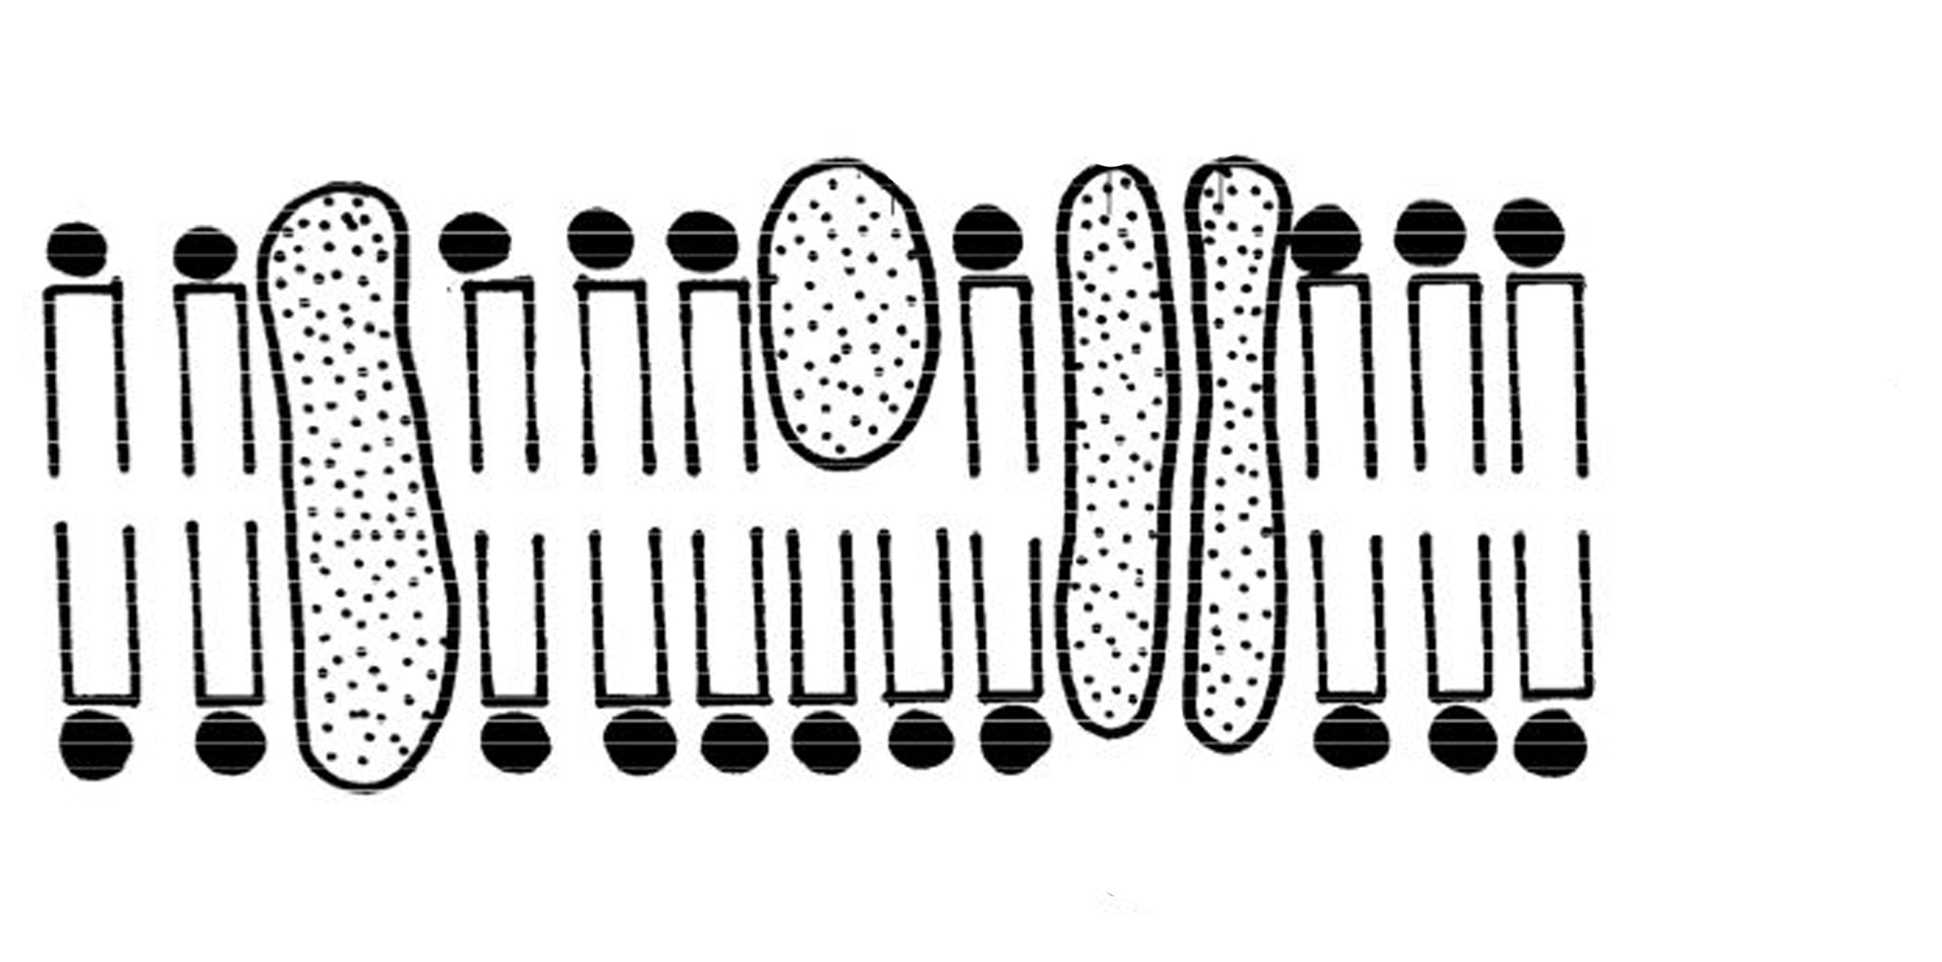
(a lipoprotein structure):
Na¹⁺

OUT
(extra-cellular fluid)

IN
(cytoplasm)

- What would you add to this drawing to clearly indicate that it was active transport taking place? Draw it on the diagram.

- Is this type of transport dependent on the [ ] gradient? Explain.

3. ATP is like a rechargeable battery. Explain this concept.

4. THINK: How does ADP ‘make its way’ back to the mitochondria to be recharged?

