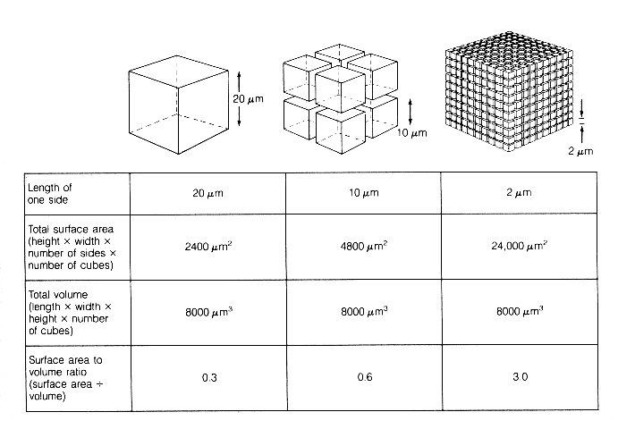
Surface Area to Volume Ratio in Cells
3:1
0.6:1
0.3:1

This diagram is good as it compares what happens when you increase the surface are of the same original cube. The bottom row of the graph shows have the surface area has been greatly increased by cutting the cube and forming lots of little ones.

Note: in this case they have not left the ratio as SA:V, but actually done the division SA/V, and given the number.

1:3

