Communication and Collaboration

Development
Influence
Application and Limitation
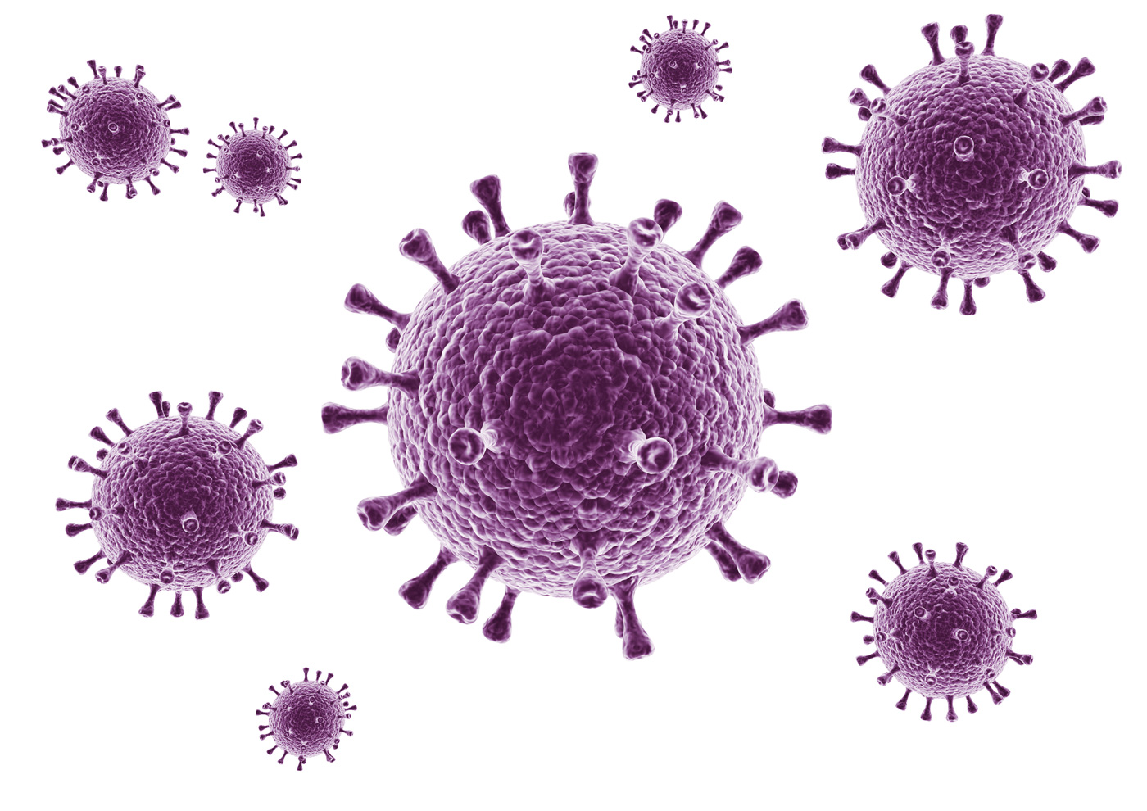
Stage 1 Biology – SHE & Intro to Cells & Viruses

How to build synthetic DNA and send it across the internet
https://www.ted.com/talks/dan_gibson_how_to_build_synthetic_dna_and_send_it_across_the_internet

Australian lab first outside of China to copy coronavirus, helping vaccine push
https://www.abc.net.au/news/2020-01-29/wuhan-coronavirus-created-in-australian-lab-outside-of-china/11906390

