Types of Active Transport Worksheet

1. The two main categories of active transport are ENDOCYTOSIS and EXOCYTOSIS. Briefly explain the difference between the two main types.

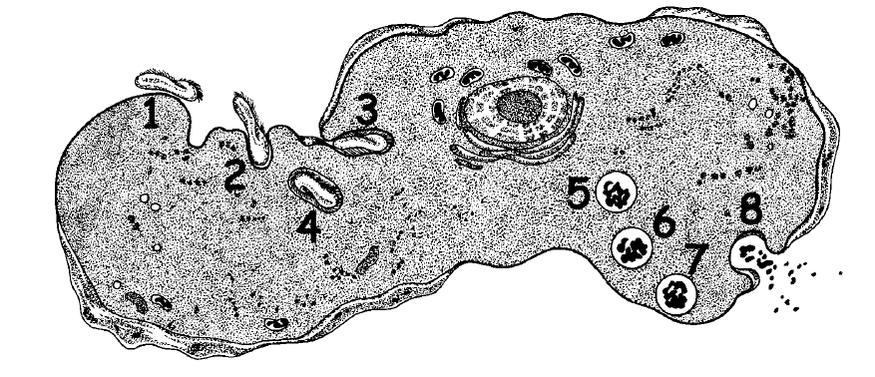
2. Examine the diagram of the cell below. Steps 1-4 and steps 5-8 reveal two different processes taking place.

- Explain what may be happening in steps 1-4?

- Explain what may be happening in steps 5-8?

c) What does ‘active transport’ mean?

d) What must happen to the membrane of the cell in each of the two different processes?

3. If passive transport does not require energy, what does it require for the movement of molecules?

4. ATP is the key energy form found in living things.

- Explain where ATP comes from in the cell.

- Draw a simple diagram to show how ATP molecules can be compared to rechargeable batteries.

5. Draw a diagram showing active transport using an ion pump that is pumping Na¹⁺ ions into the cell against the concentration gradient.

