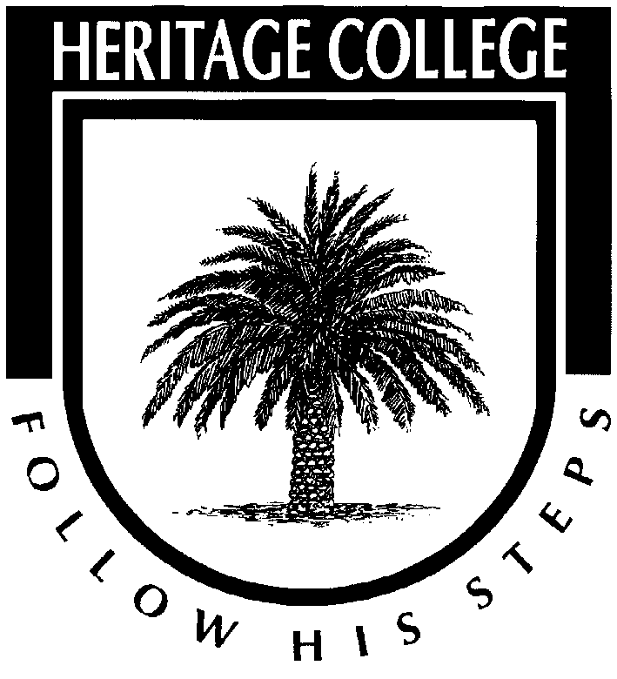
Stage 1 Biology

Course information

Heritage College
A Christadelphian School
Adelaide, Australia

Major Topics

- Cells
- Biodiversity and Ecosystem Dynamics
- Integrated: Human Endeavour & Science Inquiry Skills

Formative Assessment

You will develop your learning and receive feedback by way of the following assessments throughout the year:

- Short assignments (typically short answers or extended response)
- Short research/investigations
- SHE task mini assignments
- Lab reports
- Tests and quizzes (typically 1-2 for each major topic)
- Retrieval practice

Summative Assessment Tasks

Investigations folio | 50% | Factors Affecting Osmosis Practical & Report
 |  | Keystone Species Investigation
Skills and applications tasks | 50% | Cells and Microorganisms Test
 |  | Biodiversity and Ecosystem Dynamics Test
Information on the Final Exam

The 2 hour final examination consists of:
- Formative Section = Cells
- Summative Section = Biodiversity and Ecosystem Dynamics Test

