Stage 2 Biology
FORMATIVE SACE Test

Topic: Cells as the Basis of Life
Heritage College
A Christadelphian School
Adelaide, Australia

ANSWERS

Section A: Multiple-Choice Questions
1 = L 2 = L 3 = M 4 = M 5 = M
6 = J 7 = L 8 = K 9 = K 10 = M

Section B: Short Answer

Question 1
- Correct balanced equation for photosynthesis
- Respiration (catabolic reaction)
- DNA synthesis in S phase; protein synthesis for development of enzymes needed
- In order to pass on a complete set of DNA to the two new identical daughter cells.
- i) Telophase; nuclei start to reform, chromosomes start to decondense,
ii) vesicles are used to store and transport materials around inside the cell for more efficient transport; they are used in the process of exocytosis to transport materials to the outside of the cell
- i) they are all genetically identical so they are more prone to pathogens; all individuals are likely to be lacking the disease resistant genes so all are at risk
ii) The food source which the people depended on was lost which led to starvation/malnutrition
- i) increases crop yields; increases profits; reduces wastes
ii) sexually reproducing organisms have greater potential for genetic diversity (through crossing over, independent assortment, and random fertilization) and passing on different combinations of genes – some of these may turn out, with the help of mutation, to give the plant disease resistance. Asexually reproducing plants will not have the ability to have such genetic variation as they are identical and so will be less likely to develop resistance.

Question 2
- Because there is such a large amount of biochemical reactions taking place here the organelle needs many proteins to make enzymes. Having its own DNA means it can make its own proteins and rRNA on site for rapid and efficient use.
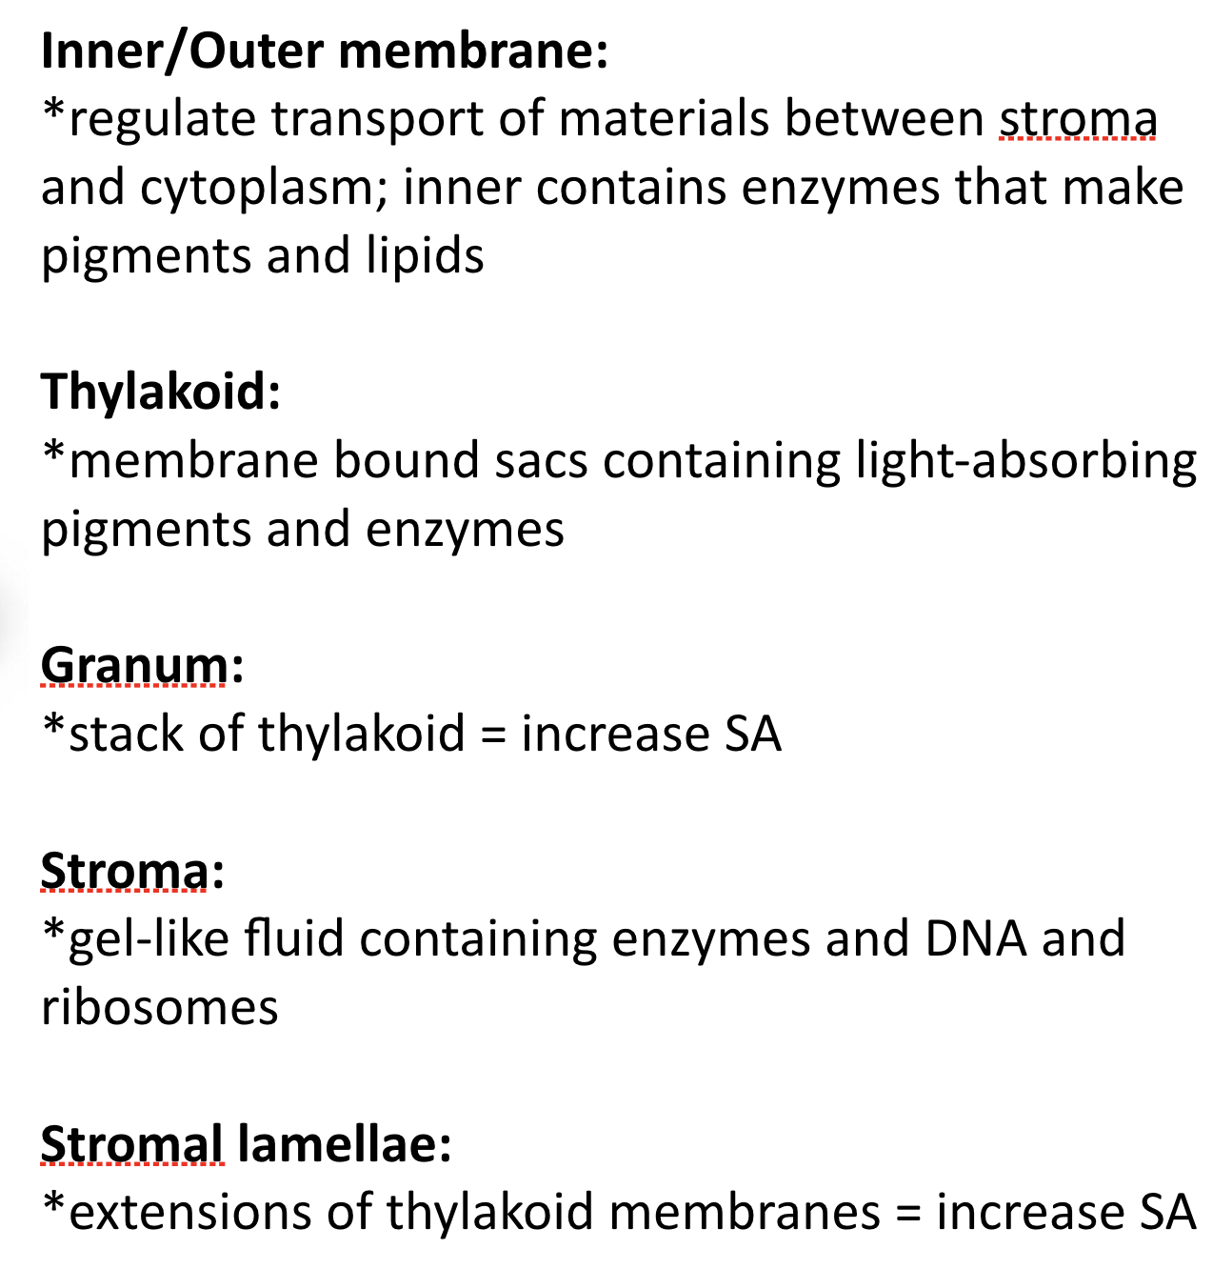
- Any of the following:

- Glucose production in the cells relies on light penetrating the cell. With all of the parenchymal cells stacked upright you can increase the amount of cells receiving the sunlight as light shines down them. In this way no cell is blocking other cells, and the efficiency and amount of photosynthesis is greatly increased.
- The phloem cells will use glucose to make ATP. If the sugar is actually in sucrose form this will prevent or slow the phloem cells from using up the sugar to make ATP as it moves down to the roots where it is needed.

Question 3
- If the haemoglobin proteins were dissolved in the blood this would increase the overall solute concentration in the blood. With a greater solute concentration in the blood it would be more hypertonic compared to the tissue cells, and water would leave the tissue cells by diffusion into the blood. The result could be that they turn flaccid.
- Continuous flow of blood ensures that there is always a concentration gradient (difference) maintained between the blood and surrounding cells. This is needed for diffusion. If they blood stopped the concentration gradient would eventually even out and no transport would take place in or out of the blood.

Section C: Extended Response

The first step in culturing plants would be to remove a small piece of the desired plant, called an explant, using careful dissection techniques. This then can be taken to a specific growth medium where the plant cells will be induced to divide and grow, using various growth factors that are needed. These cells will grow and form a callus. This is then treated carefully with the right amounts of growth hormones in start root and shoot growth. Once these have grown they can be transferred to soil to grow in the right conditions.

Without growth hormones in culturing process, the plant cells will not divide and grow in the way that they need to for effective plant development. Various growth hormones will be needed at stages in the culturing to ensure that the right plant anatomy develops at the right time – for example roots and shoots that will eventually form leaves. Without the hormones the cells may stop dividing, or may never develop parts of the plant that are needed.

Benefits of plant culturing could include producing crops of identical plants that have the same genes for disease resistance or resistance to pesticides that kill other weeds. This would have a direct result on crop yield, allowing farmers to increase productivity. The other benefit from this is more efficiently farming to provide food for countries in need. Another benefit of plant culturing includes the ability to save species of plants that are at risk of extinction. By taking samples of their tissues and culturing new plants this increases the population.

