Experimental Skills – Biology Reports

Variables
Many experiments involve changing one quantity and measuring the effect on another quantity.
- The quantity being deliberately changed is called the ‘independent variable’.
- The quantity that changes as a result is called the ‘dependent variable’.
- All other factors are held constant, if possible, throughout an experiment.
- Some factors may not be able to be controlled. It is important to identify these.

Graphs
When a graph is plotted:
- The independent variable (or a quantity calculated from it) is plotted horizontally (x axis)
- The dependent variable (or a quantity calculated from it) is plotted vertically (y axis)
Every graph should include a title and labelled axes with appropriate scales and units.
Relationships between variables in an experiment can be shown by a line (or curve) of best fit.
- The plotted points should be scattered evenly above and below the line of best fit
- The line of best fit does not necessarily pass through the origin of the graph.
If a straight line of best fit passes through the origin of the graph and is a good representation of the data, the plotted quantities are directly proportional to each other.

Random and Systematic Errors (Uncertainty)
Every measurement is affected by random and/or systematic errors.
Random errors cause each measurement to differ from its true value by a random amount, leading to scatter in the measured values. Increasing the sample size minimises the effects of random errors.

Systematic errors are present when measured values differ consistently from the true value, leading to a shift in the line of best fit.
Systematic errors can be identified and results verified by repeating an experiment, using an alternative source of equipment and materials.
Mistakes made by the experimenter are not considered to be sources of uncertainty because they should be avoided or corrected during the experiment.
Validity, Reliability and Accuracy
The validity of an experiment is how appropriate the method is to the aim of the experiment. If the equipment, steps, or analysis are relying on incorrect assumptions, the results are less valid.
The reliability of measurements is how repeatable they are. Random errors decrease the reliability of measurements (because you might get a different result each time), and depend on the precision (exactness/detail) of the measuring equipment.
The resolution of a measuring instrument is the smallest increment measurable.
- Using equipment with better resolution will allow for more precise measurements.
- Usually the range of possible random error is plus or minus (±) half the smallest measurement on the equipment.
- The number of significant figures used to record measurements should be appropriate to the resolution.
The accuracy of a measured value is how close it is to the true value. Systematic errors decrease the accuracy of measurements, because all the values could be consistently too large or small.
The calibration of a measuring instrument is how close its values match the true values. Poorly calibrated equipment is a possible source of systematic error.

Evaluation of procedure and suggestion for improvements
- Mention any evidence of error in the data (e.g. scatter; departure from class average)
- Identify sources of uncertainty, including random and systematic error and uncontrolled factors
- For each source, compare the amount of effect it would have on the data with the evidence
- Things that should be mentioned somewhere:
  - Reliability, accuracy, and validity of results
  - How the effect of random errors can be minimised (or was minimised, if relevant)
  - How systematic error could be detected

Analysis of data to formulate a conclusion
- Use the line of best fit on the graph to determine the mathematical relationship
- Discuss any concepts relevant to the formulas
- Restate the hypothesis and conclude whether the results support it or not
- Include any limitations of the experiment

In the graphs below, the dotted line shows the true values.
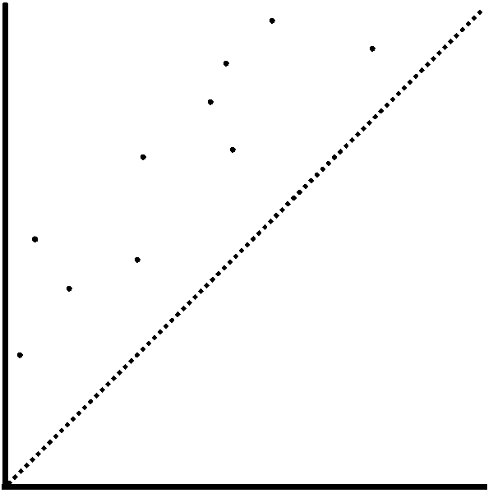  Low reliability (significant random error)  Low accuracy (significant systematic error) | 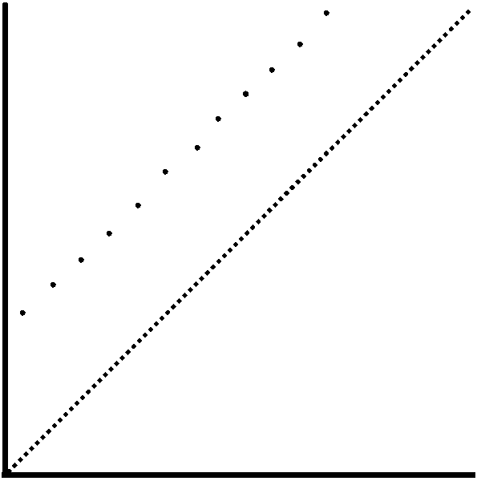  High reliability (little random error)  Low accuracy (significant systematic error)
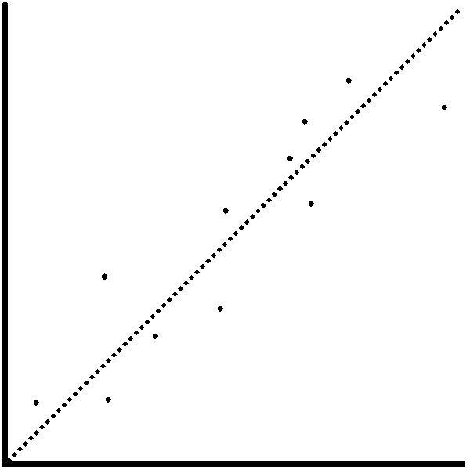  Low reliability (significant random error)  High accuracy (little systematic error) | 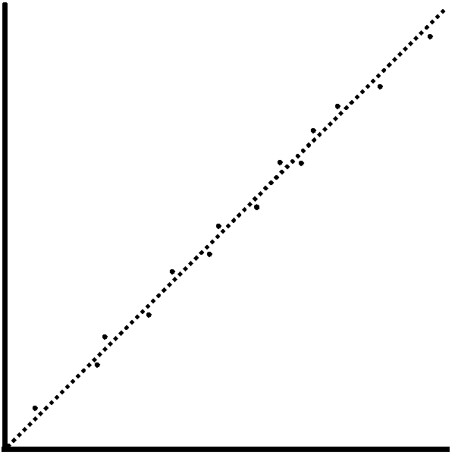  High reliability (little random error)  High accuracy (little systematic error)

