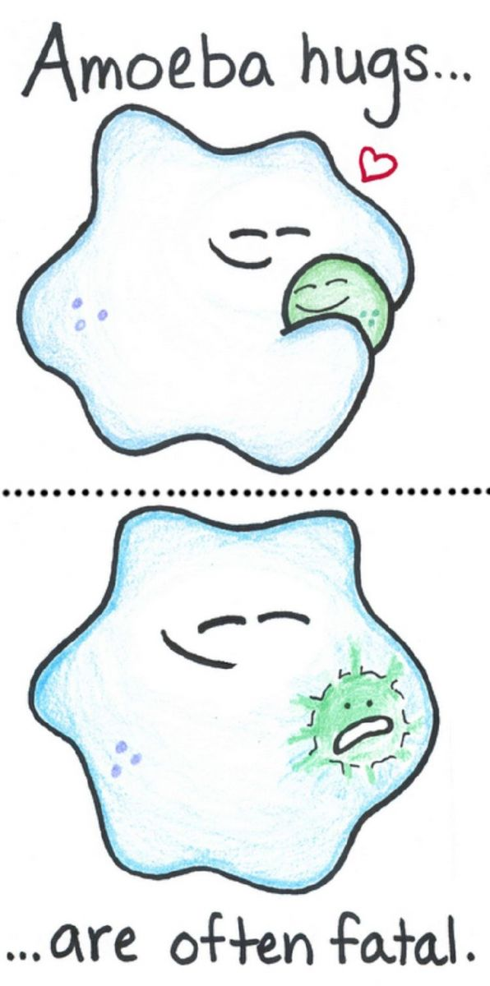
Stage 2 Biology
Cells Retrieval Quiz | 2.1 – 2.3 |

- A cell is producing a protein-based hormone in order to secrete it into the blood stream. Explain how the ER, Ribosome, and Golgi Body are connected in this process. (4)

- Sketch a diagram of a chloroplast with all of the key structures. Label what you can and give details about any of the structures and their function. (4)

- Compare and contrast the products of the three types of respiration found in living cells. (3)

- Proteins that change their shape can be found present in passive and active transport methods. Explain by comparing and contrasting these. (3)

- There were two cells. One had a large surface area and the other had a lot less surface area. Which one will do diffusion and osmosis more efficiently? Justify your thinking. (3)

