Types of Passive Transport Worksheet

1. List three types of passive transport:

a)

b)

c)

2. Examine the diagram below.
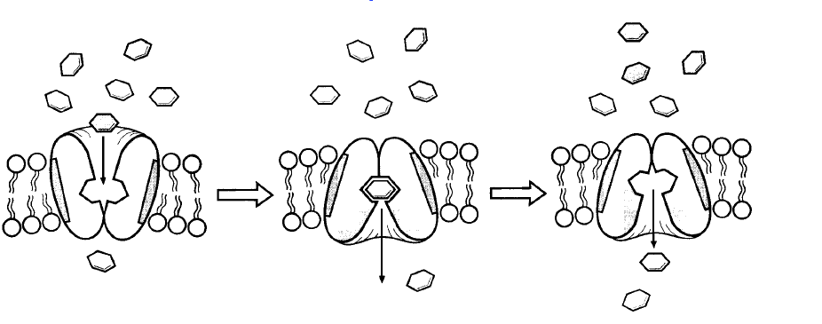

- Label as many different parts as you can on this diagram (about 5 things).

- This is a type of passive transport.

i. What does ‘passive transport’ mean?

ii. What type of passive transport is this diagram showing?

iii. Explain in words how this process takes place.

3. Draw a diagram showing passive transport of a molecule into a cell, with a simple permease protein.

