**Cell Cycle Worksheet**

1. Examine the diagram below of a typical cell life cycle. G1, G0, S and G2 are all phases that make up Interphase (I). Interphase generally lasts at least 12 to 24 hours in mammalian tissue.

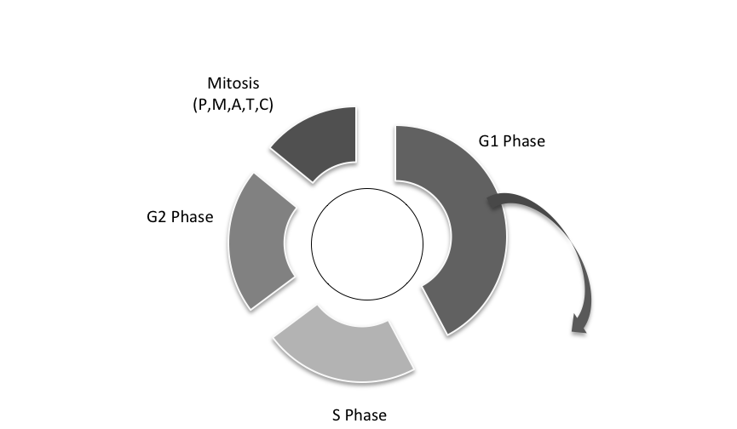

G0 Phase

1. Mark on the diagram the point that represents the beginning of new daughter cell.
2. Explain the difference between S Phase and Mitosis.
3. Some cells enter into G0 Phase once they have reached maturity. Give an example of a type of cell that may enter into this phase and remain there for the rest of its life-span. Offer a reason why this type of cell would do this.
4. Some cell types do not enter into the G0 Phase. Give a possible example of one, and why it would not be useful to enter this phase.
5. Some cell types may enter into G0 phase for a time, and then be stimulated by the body to return to the normal cell cycle. Give a possible example of a cell type that might do this, and why.

2. There are two main types of ‘cell death’ – when the cell cycle stops. The two types are described below:

**Necrosis:** when cells are exposed to extreme stress, which results in damage to its plasma membrane; cells are no longer able to maintain homeostasis; impairment ultimately results in death

**Apoptosis:** a mode of cell death that can occur under normal environmental conditions; the cell itself is an active part of its own destruction; often referred to as ‘programmed cell death’

1. Using an example from human body tissue, describe a possible situation, which may involve cell necrosis.
2. Using an example from human body tissue, describe a possible situation, which may involve cell apoptosis.

3. Examine the diagram below. This version includes ‘cell cycle checkpoints’. These are critical points in the cell cycle, which act as ‘quality control’ points. At each point the cell is checked to make sure all is well.



G0 Phase

G1 checkpoint

S checkpoint

G2 checkpoint

M checkpoint

1. What ‘quality control’ check would be happening at the S checkpoint, before the cell moves into G2 Phase?
2. If the G2 checkpoint found that there were irreparable problems in the cell at this stage in the cycle, what might the cell do?
3. Predict what might go wrong with a cell, if its M checkpoint was not functioning.