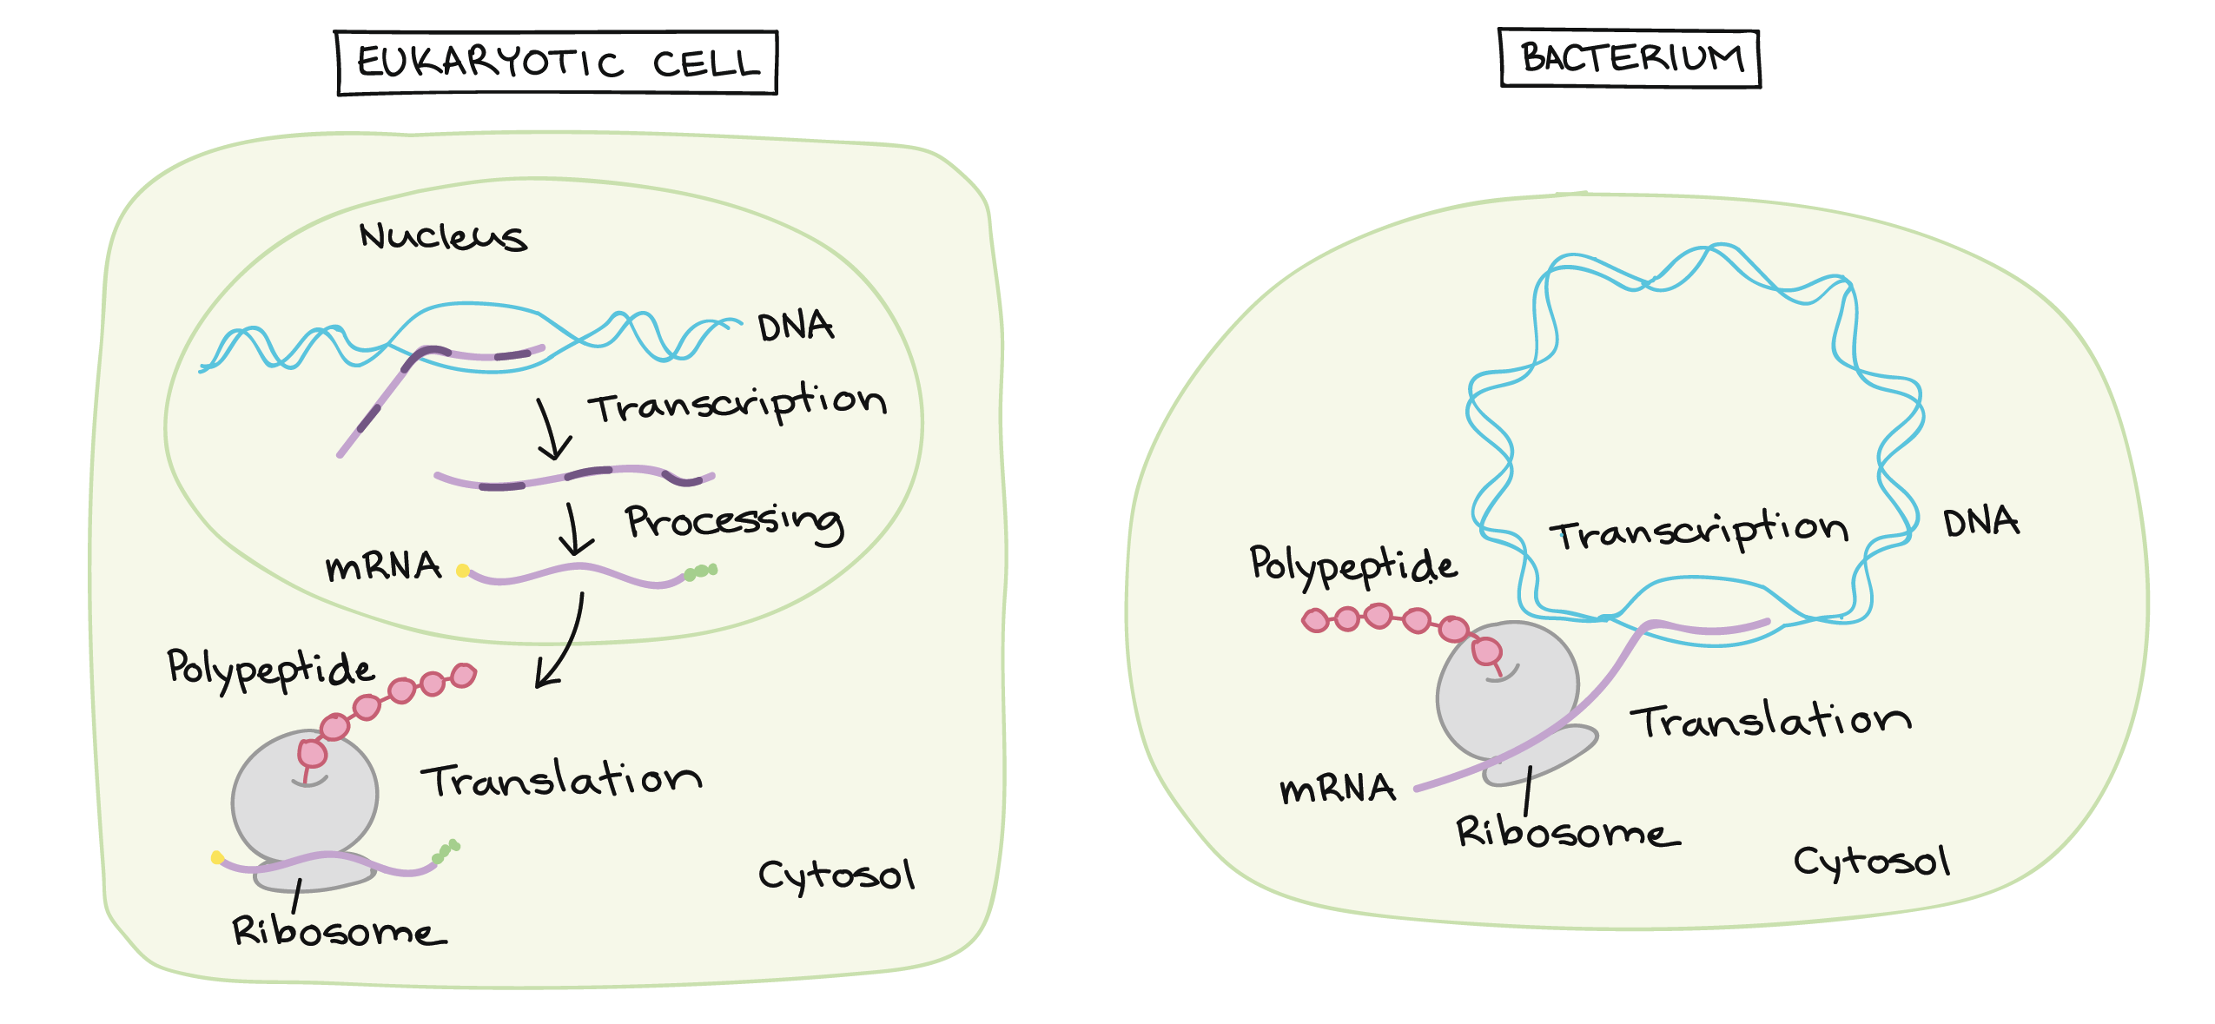

Pre-RNA Processing in Eukaryotes Compared to Bacterium