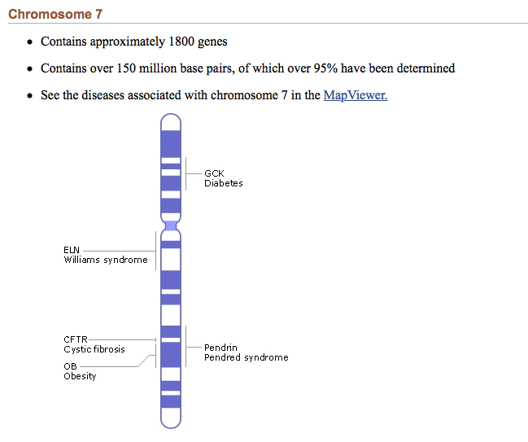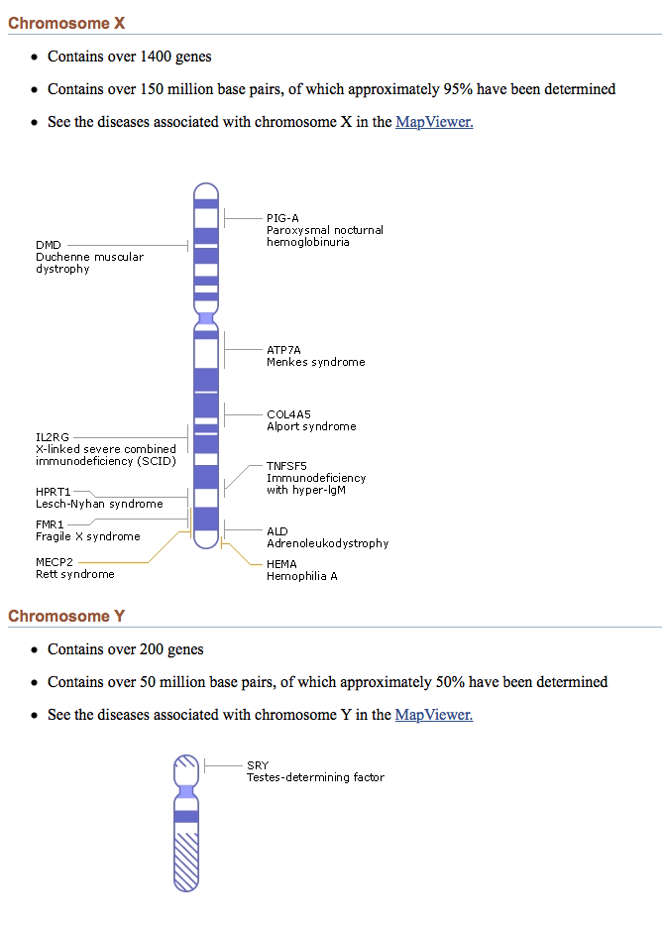

**Human Chromosome Map**

**Nation Centre for Biotechnology Information**

**Gene Locus** = exact location where gene is found on a particular chromosome

http://www.ncbi.nlm.nih.gov/books/NBK22266/#A287