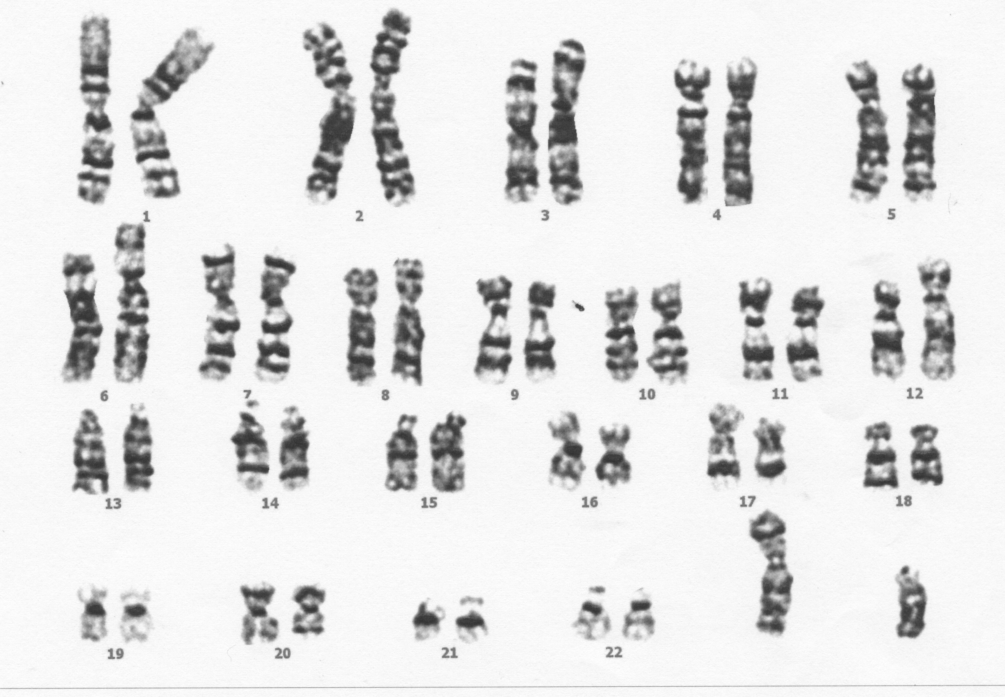
Human Male Karyotypes
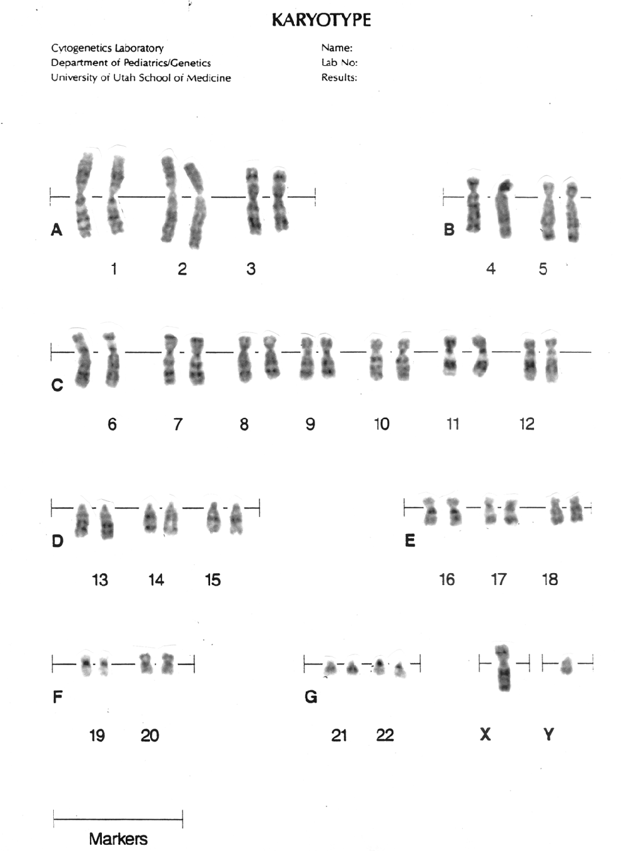

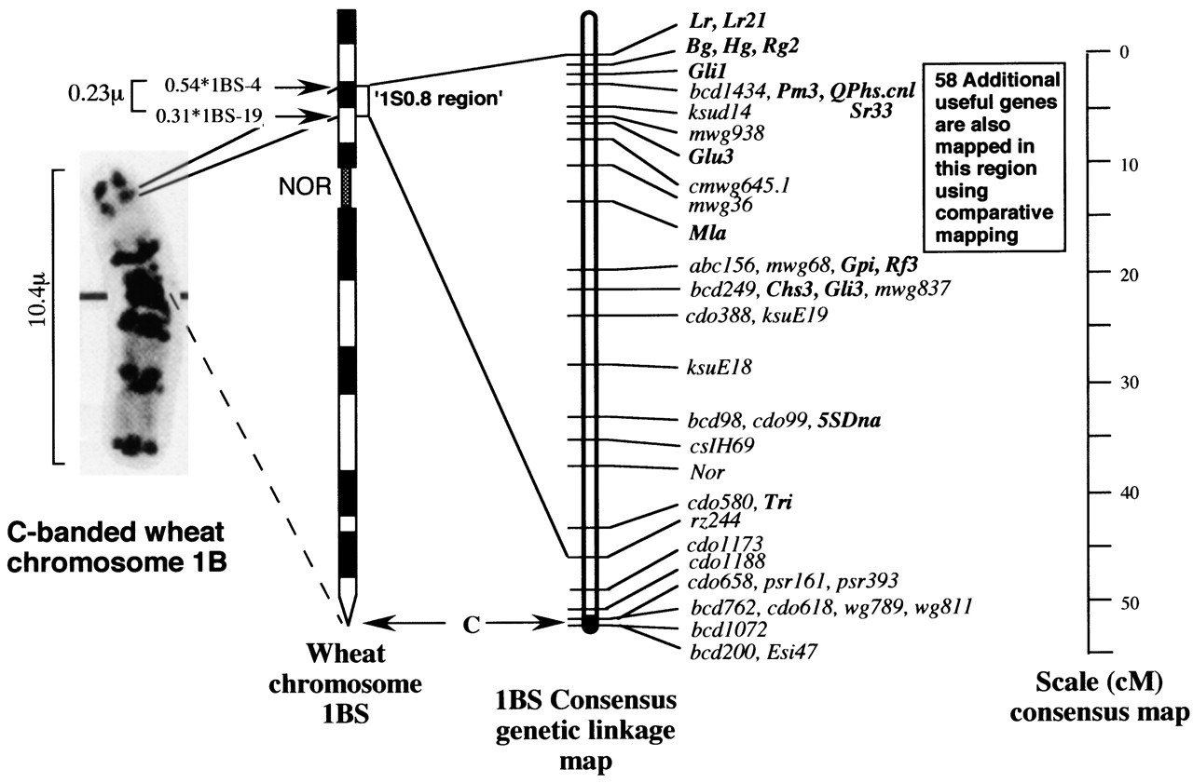
Wheat Chromosome 1B
Showing all mapped genes specific to this chromosome.

