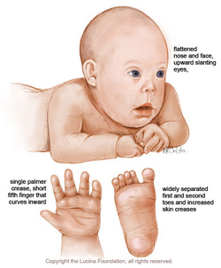

**Importance of Two Key Enzymes in Phenylalanine Biochemical Pathway**

phenylananine

hydroxylase

tyrosinase

albinism

phenolketonuria

phenylalanine

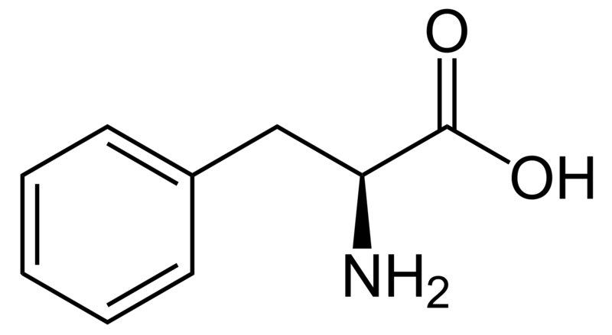

tyrosine

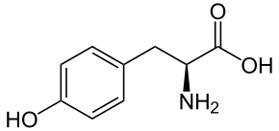

dopachrome

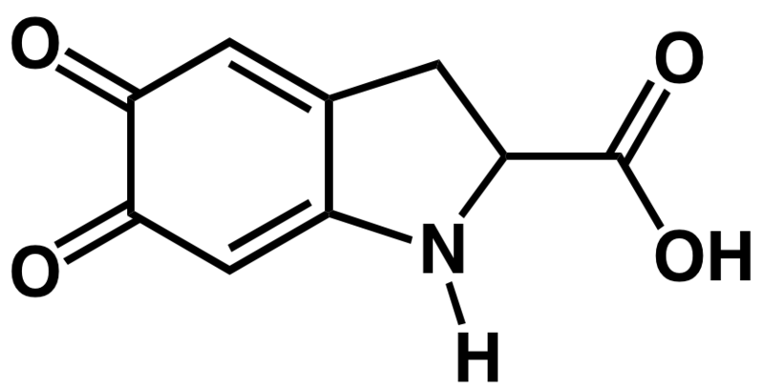

**MELANIN**

**pigment**

phenylananine

hydroxylase

tyrosinase