Transcription Factors

- Transcription factors are proteins that help turn specific genes "on" or "off" by binding to nearby DNA.
- Transcription factors that are activators boost a gene's transcription. Repressors decrease transcription.
- Groups of transcription factor binding sites called enhancers and silencers can turn a gene on/off in specific parts of the body.

Promotor Sequence
This is a special DNA sequence before the gene of interest. The RNA polymerase binds this spot in order to start transcription.

In eukaryotes RNA polymerase needs the help of other proteins called transcription factors to help it bind to the promotor. These are part of the cell’s transcription ‘toolkit’ needed for transcription of any gene.

These transcription factors are one of the keys that determine whether a gene is transcribed or not – their presence and how they interact can control the gene expression. They can make it either hard or easy for RNA polymerase to bind to the promotor.

Some work as ‘activators’ for the gene:

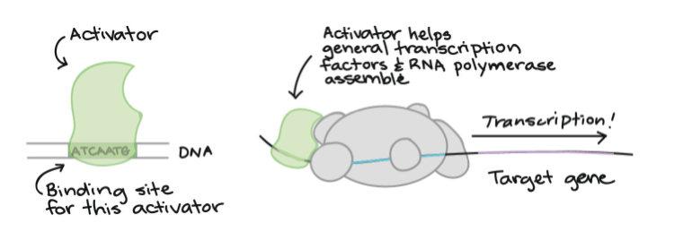
RNA
polymerase

Some work as ‘repressors’ for the gene:

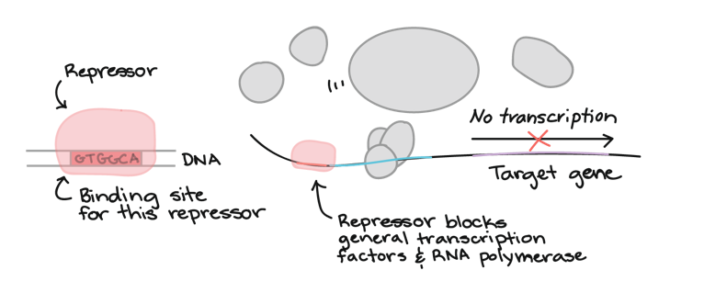
RNA
polymerase
Multiple Transcription Factors

Many genes are controlled by several different transcription factors, with a specific combination needed to turn the gene on.

For instance, a gene may be expressed only if activators A and B are present, and if repressor C is absent.

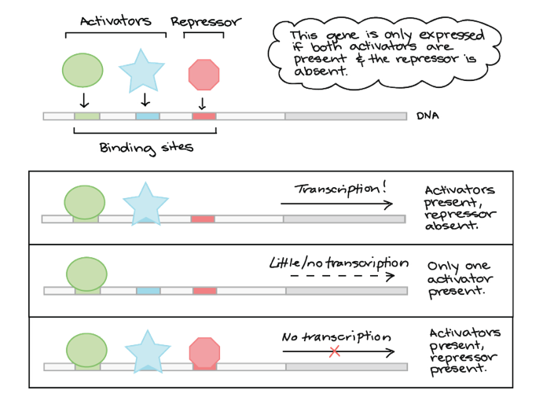
B
A
C

The use of multiple transcription factors to regulate a gene means that different sources of information can be integrated into a single outcome. For instance, imagine that:
- Activator A is present only in skin cells
- Activator B is active only in cells receiving "divide now!" signals (growth factors)
from neighbors
- Repressor C is produced when a cell's DNA is damaged

In this case, the gene would be "turned on" only in skin cells that are receiving division signals and have undamaged, healthy DNA. This pattern of regulation might make sense for a gene involved in cell division in skin cells. In fact, the loss of proteins similar to repressor C can lead to cancer.

Real-life combinatorial regulation can be a bit more complicated than this. For instance, many different transcription factors may be involved, or it may matter exactly how many molecules of a given transcription factor are bound to the DNA.

