

**Heritage College**

A Christadelphian School

*Adelaide, Australia*

Stage 2 Biology

FORMATIVE SACE Test

**Topic: Evolution**

|  |
| --- |
|  |
|  |

**Section A: Multiple-Choice Questions – Select the most correct answer.**

1. *Refer to the following diagram, which shows an organelle found in a eukaryotic cell:*

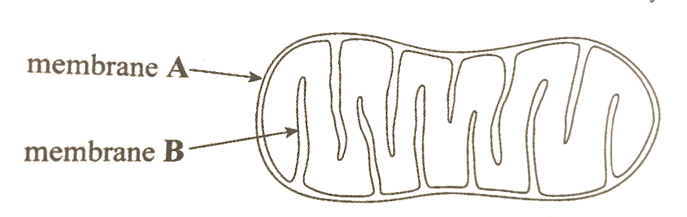

The organelle shown above is thought to have evolved by endosymbiotic events approximately 1.5 billion years ago.

Which one of the following combinations identifies the organelle, the origin of membrane **A**, and the origin of membrane **B**?

|  |  |  |  |
| --- | --- | --- | --- |
|  | **Organelle** | **Origin of membrane A** | **Origin of membrane B** |
| **J** | Mitochondrion | Prokaryote | Host cell membrane |
| **K** | Chloroplast | Host cell membrane | Prokaryote |
| **L** | Chloroplast | Prokaryote | Host cell membrane |
| **M** | Mitochondrion | Host cell membrane | Prokaryote |

2. Which one of the following statements is (according to evolutionary theory) **evidence** that prokaryotic cells existed **before** eukaryotic cells?

**J** Prokaryotic organisms are single-celled and less complex than eukaryotic cells.

**K** The oldest-known prokaryotic fossils are at least 3.5 billion years old whereas the oldest-known eukaryotic fossils are at least 1.5 billion years old.

**L** Prokaryotic organisms are able to live and thrive in hostile environments such as hydrothermal vents, swamps, and wetlands.

**M** The cells of prokaryotic organisms do not contain membrane-bound organelles whereas the cells of eukaryotic organisms **do** contain membrane-bound organelles.

3. *Refer to the following diagram, which shows possible evolutionary relationships based on DNA evidence (according to the theory of evolution):*

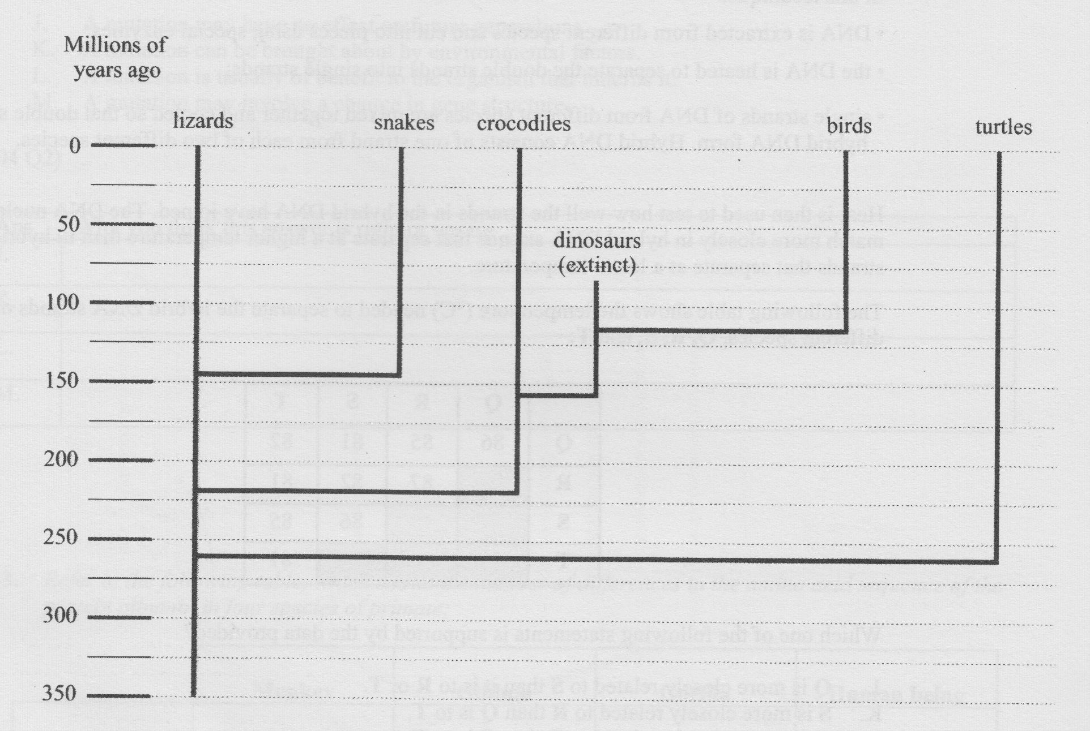

It is reasonable to conclude from the information in the diagram above that there

**J** would be more similarity between dinosaur DNA and bird DNA than between dinosaur DNA and snake DNA.

**K** has been no change in lizard DNA in 350 million years.

**L** is more variation in turtle DNA than in bird DNA.

**M** is less similarity between snake DNA and lizard DNA than between snake DNA and crocodile DNA.

4. Sometimes related species of lizards living in the same community have been observed to recognize each other’s courtship behaviour and mate. However, the offspring never become adults. This situation is called

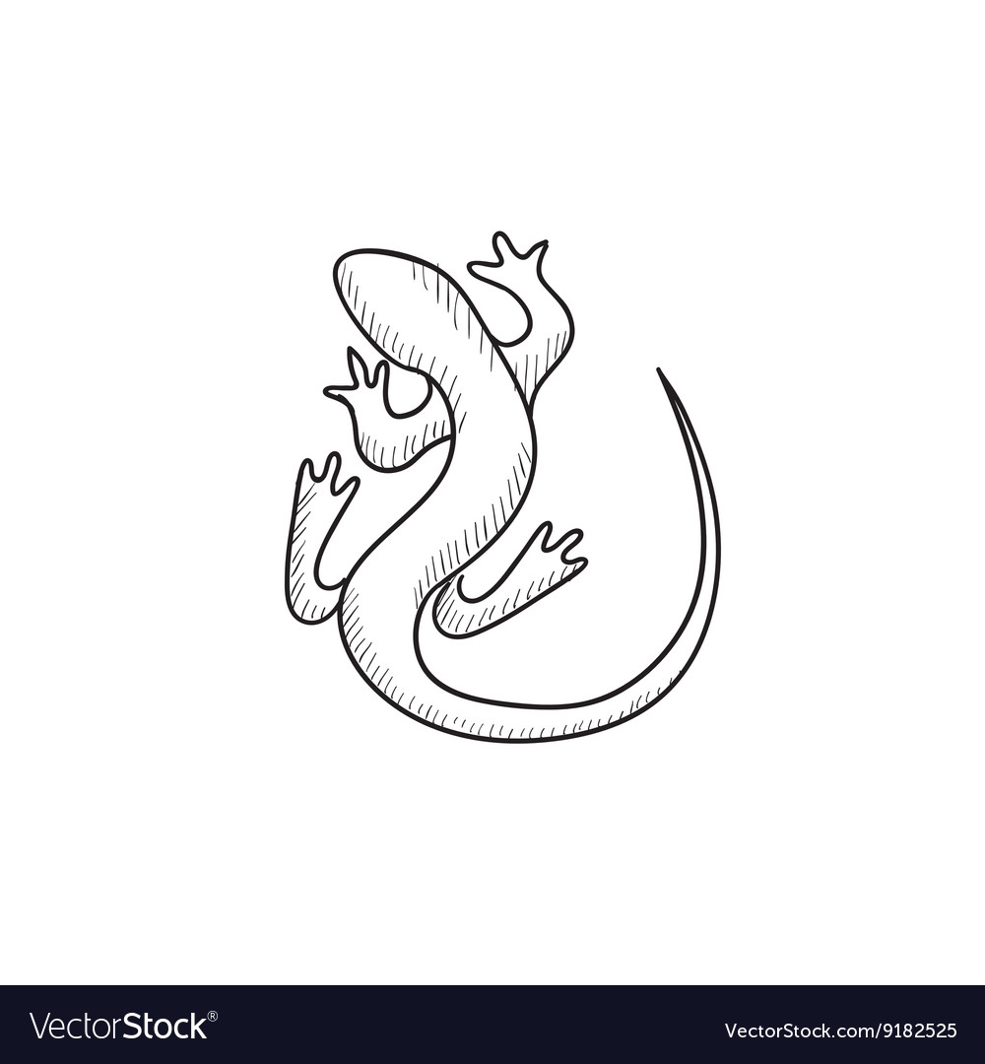

**J** geographic isolation.

**K** post-zygotic reproductive isolation.

**L** pre-zygotic reproductive isolation.

**M** sympatric isolation.

This lizard is just to fill this space. When you are done your test, feel free to colour it in and give it eyes. BUT ONLY when you are done!

5. Which of the following statements about natural selection is ***incorrect***?

Natural selection may

**J** result in an increase in the percentage of well-adapted individuals in a population.

**K** cause new genes to appear in a gene pool.

**L** result in an increase in the frequency of favorable genes in a gene pool.

**M** occur in stable environmental conditions.

6. Which of the following statements is ***incorrect***?

**J** Divergent evolution is the accumulation of differences between related groups, leading to the formation of new species.

**K** Adaptive radiation is a process in which organisms diversify rapidly from an ancestral species into an array of species with different traits.

**L** Convergent evolution differs from divergent evolution in that the species involved are different while the traits they obtain do not differ from one another.

**M** Convergent evolution is the development of a similar trait, for example the development of horns, in species descending from the same ancestor.

7. Roxby Island and West Franklin Island, both off the coast of South Australia, were (according to the theory) once part of mainland Australia, which extended to the edge of the continental shelf until sea level rose about 10 000 years ago.

The tiger snakes on the two islands are now very different, although there is evidence that 12 000 years ago they were very similar. Those on West Franklin Island grow to a very large adult length of about 150cm, while those on Roxby Island grow to an average length of just 80cm.

Both the West Franklin snakes and the Roxby Island snakes breed every second year in spring and give birth in summer.

It is expected that over time, these two populations of tiger snakes will become so different that they will be considered two distinct species.

Which one of the following combinations best describes the type of speciation, the type of evolution and the mechanism in this situation?

|  |  |  |  |
| --- | --- | --- | --- |
|  | **Type of Speciation** | **Type of Evolution** | **Mechanism** |
| **J** | Sympatric | Divergent | Reproductive isolation |
| **K** | Allopatric | Divergent | Geographic barrier |
| **L** | Sympatric | Convergent | Geographic barrier |
| **M** | Allopatric | Convergent | Reproductive isolation |

8. The eastern brown snake (*Pseudonaja textilis*) and the common death adder (*Acanthophis antarcticus*) are species of snake found throughout Australia.

*The following table provides information for each of these species, about habitat(s), food, method of obtaining food, and change on population size since European settlement of Australia:*

|  |  |  |
| --- | --- | --- |
|  | **Eastern brown snake** | **Common death adder** |
| **Habitat(s)** | Cleared land with little vegetation | Coastal dune and mallee |
| **Food** | Lizards, frogs, and mice | Lizards and birds |
| **Method of obtaining food** | Actively searches for food | Lies, covered by leaves, and waits for prey |
| **Change in population size since European settlement of Australia** | Increased | Decreased |

Since European settlement, coastal dune and mallee habitats have been extensively cleared. The ` clearing of the remaining coastal dune and mallee habitats should

**J** proceed because the common death adder serves no useful purpose in these habitats.

**K** not proceed because it will prevent competition between the eastern brown snake and the common death adder.

**L** not proceed because these habitats provide all the conditions necessary for the survival of the common death adder.

**M** proceed because it will assist the survival of the eastern brown snake in these habitats.

9. Human activities like land clearing and agriculture can create pressures on species leading to their extinction.

Which one of the following combinations best describes the size of the gene pool, the susceptibility to extinction and the amount of genetic diversity?

|  |  |  |  |
| --- | --- | --- | --- |
|  | **Size of gene pool** | **Susceptibility to extinction** | **Amount of genetic diversity** |
| **J** | Small | More susceptible | Low |
| **K** | Large | More susceptible | High |
| **L** | Small | Less susceptible | High |
| **M** | Large | Less susceptible | Low |

**Section B: Short Answer**

1. Populations of a species of fish were found living in several small shallow lakes up to 50 kilometers apart in northern South Australia in an area well known for its hot springs. An initial investigation showed that the temperature range of each of the lakes was between 30oC and 35oC. A small number of this species of fish from each of the lakes were tested in the laboratory to find the temperatures they could tolerate. None of those tested survived at temperatures below 27oC.

The largest of the lakes, called Lake **A**, is thought to have the largest population and to the be oldest.

Over several years it was observed that the temperature of one of the lakes (Lake **B**) was falling. A study made 50 years after the initial investigation showed that some of the members of this species of fish were living in Lake **B** even though its temperature was now between 21oC and 26oC.

(a) State the name given to all the genetic information within the population of this species of fish in Lake **B**.

________________________________________________________________________

(1)

(b) Describe the process that resulted in some members of this species of fish in Lake **B** having the ability to survive at lower temperatures (21oC and 26oC) 50 years after the initial investigation.

________________________________________________________________________

________________________________________________________________________

________________________________________________________________________

________________________________________________________________________

________________________________________________________________________

(2)

(c) The population of fish in Lake **A** differ genetically from those in Lake **B** more than fish from any of the other lakes even though they are the same species. **Describe** one technique that scientists may have used to accurately determine how genetically similar the different populations of fish are.

________________________________________________________________________

________________________________________________________________________

________________________________________________________________________

________________________________________________________________________

________________________________________________________________________

(3)

(d) The population of fish in Lake **A** also have a much greater genetic **diversity** than the smaller population of fish in Lake **B**. State and explain a process that may have led the population in Lake **B** having a reduced genetic diversity.

________________________________________________________________________

________________________________________________________________________

________________________________________________________________________

________________________________________________________________________

________________________________________________________________________

________________________________________________________________________

(3)

2. One method of conserving endangered bird species involves capturing mainland birds and establishing small populations of them on isolated offshore islands. These islands are chosen because they are free from introduced species that are found on the mainland.

*Refer to the following diagram, which shows data about the environment of a mainland population of an endangered bird species, and data about the environment on two nearby offshore islands.* ***L*** *and* ***M****:*

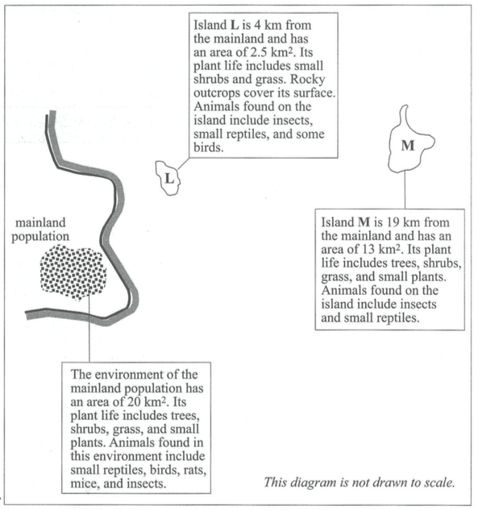

(a) State one way in which ***non-predatory*** animals introduced to the mainland may contribute to the declining population of these birds.

________________________________________________________________________

(1)

(b) State and explain which of the two islands (**L** or **M**) seems to have characteristics that reveal a more advanced stage of succession. Justify your thinking.

________________________________________________________________________

________________________________________________________________________

________________________________________________________________________

________________________________________________________________________

________________________________________________________________________

(2)

(c) The birds in the mainland populating are known to nest among the long grass and low shrubs in the shelter of trees. They feed on seeds, insects, and small reptiles.

Scientists decide to move a number of endangered birds from the mainland population to one of the nearby offshore islands. They establish the new population on island **M** rather than on island **L** to minimize the risk of speciation.

Explain why a population on island **M** is less likely than a population on island **L** to result in rapid speciation.

________________________________________________________________________

________________________________________________________________________

________________________________________________________________________

________________________________________________________________________

________________________________________________________________________

(2)

(d) If the scientists move a number of birds away from the mainland population to start a new colony, there is a risk of causing the ‘founder effect’. Explain what this means.

________________________________________________________________________

________________________________________________________________________

________________________________________________________________________

________________________________________________________________________

________________________________________________________________________

(2)

(e) Explain how ‘gene flow’ between populations on mainland, island **M** and island **L** would potentially be affected if populations were established on these two islands.

________________________________________________________________________

________________________________________________________________________

________________________________________________________________________

________________________________________________________________________

________________________________________________________________________

(2)

3. Climate change (mainly due to fossil fuel emissions) is a major issue that is threatening many species of organisms on the planet. Explain, using an example of your choice, how change in climate is having adverse effects on a particular species. *Do your best to use biological terms and concepts in your description.*

________________________________________________________________________

________________________________________________________________________

________________________________________________________________________

________________________________________________________________________

________________________________________________________________________

________________________________________________________________________

________________________________________________________________________

________________________________________________________________________

________________________________________________________________________

________________________________________________________________________

(4)

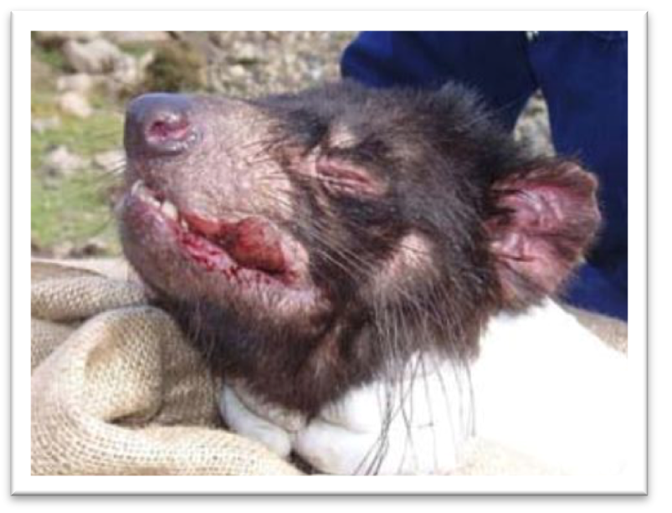4. The Tasmanian devil population on mainland Tasmania is at severe risk of becoming extinct due to the Devil facial tumour disease (DFTD) which is a type of cancer transmitted between individuals by physical contact (e.g. biting). One of the contributing factors appears to be linked to reduced diversity in the major histo-compatibility complex (MHC) set of genes which are involved in the immune response.

(a) Suggest possible factors that might have contributed to this reduced diversity in the MHC genes.

________________________________________________________________________

________________________________________________________________________

________________________________________________________________________

________________________________________________________________________

________________________________________________________________________

(2)

(b) Explain how this reduced diversity may impact on the process of natural selection, leading to this species becoming endangered.

________________________________________________________________________

________________________________________________________________________

________________________________________________________________________

________________________________________________________________________

________________________________________________________________________

(2)

**Section C: Extended Response**

*Answer on the ‘Extended Response Answer Sheet’. You should spend about 12-15 minutes on this section, about 3-5 minutes planning and 9-10 minutes writing. An ‘A’ level performance will show a clear, well-expressed answer that is well organised, relevant to the question, and demonstrates a deep and broad level of understanding.*

*Two marks awarded for clarity and coherency of response.*

**Question:**

The global human population has ‘exploded’ since the 1800s. The rate of increase since this time has been nothing short of exponential. In several long-term studies ecologists have discovered numerous connections between this growth in human population and the decline in biodiversity and also extinctions. **Discuss** ways and give examples in which an expanding population of humans has had negative impacts on the **three key categories of biodiversity**. **Explain** how maintaining biodiversity is beneficial to the human population.

(9)

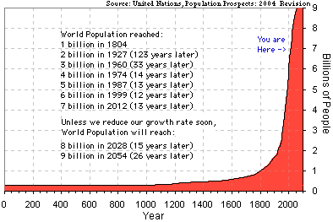

**Extended Response Answer Sheet**