Heritage College
A Christadelphian School
Adelaide, Australia

Stage 2 Biology
FORMATIVE SACE Test

DNA & Proteins B (1.1-1.6)
Section A: Multiple-Choice Questions (1 mark each)

1. In eukaryotic cells

J exons are removed from mRNA molecules after transcription
K exons are added to mRNA molecules after transcription
L introns are removed from mRNA molecules after transcription
M introns are added to mRNA molecules after transcription

2. Two DNA samples are each cut using a restriction enzyme before undergoing electrophoresis:
- sample 1 is linear DNA and is cut at four positions
- sample 2 is a plasmid and is cut at three positions

Which one of the following alternatives correctly identifies the number of bands that will be observed after the two samples separately undergo gel electrophoresis?
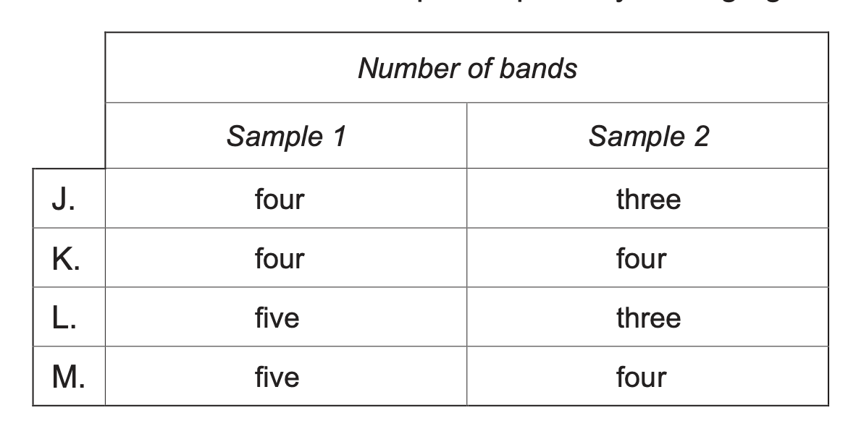

3. Immunoglobulin E (IgE) binds to receptors on mast cells, triggering symptoms associated with allergic diseases.

Researchers have found that the symptoms of these diseases can be reduced by administering anti-IgE, which binds to IgE, preventing it from binding to receptors on mast cells.

Which one of the following statements is consistent with the information above?

J Anti-IgE has a 3D shape that is complimentary to the shape of the receptors on mast cells.
K Anti-IgE has the same 3D shape as IgE.
L IgE has a 3D shape that is complimentary to the shape of the receptors on mast cells.
M IgE has the same 3D shape as the receptors on mast cells.
4. A segment of DNA is made up of strand 1 and strand 2:
- 31% of the bases in strand 1 are adenine
- 12% of the bases in strand 2 are cytosine
- 27% of the bases in strand 2 are guanine

Which one of the following statements is correct?

J Strand 1 contains 30% thymine.
K Strand 1 contains 30% guanine.
L Strand 2 contains 30% thymine.
M Strand 2 contains 31% adenine.

5. Which of the following graphs most closely resembles the effect of pH on the rate of a human enzyme-controlled reaction?

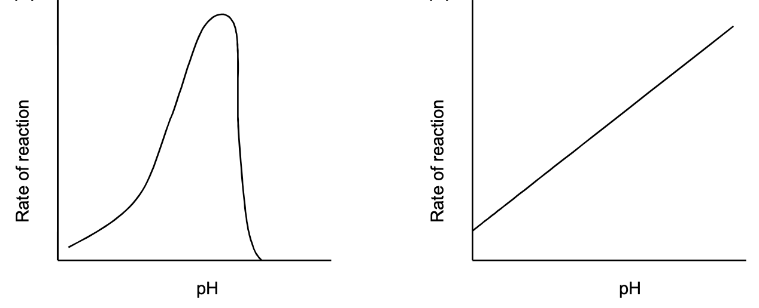
K
J

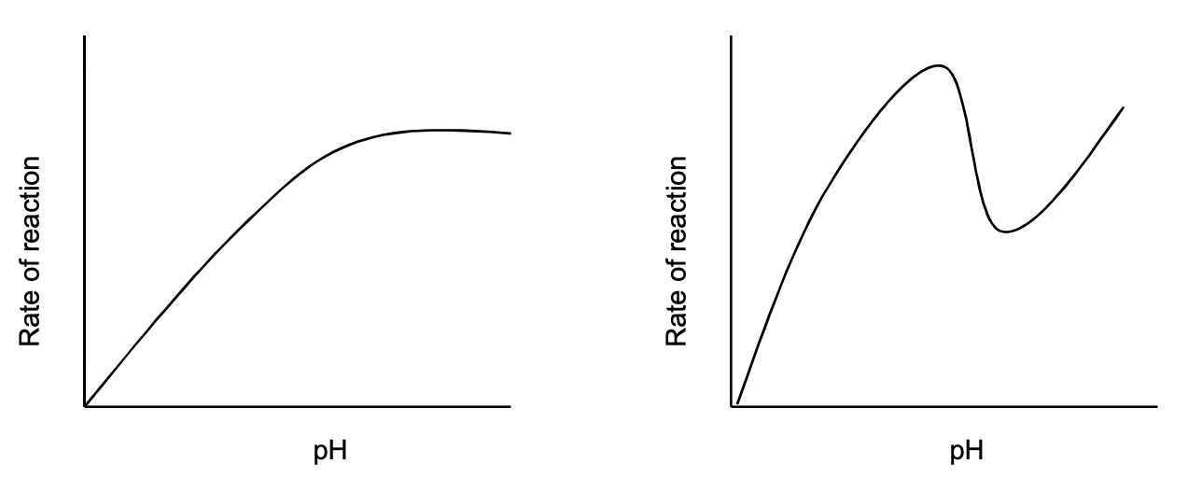
M
L

6. According to the induced fit model for enzyme action, an enzyme’s active site changes shape:

J when it binds to its substrate.
K in order to work with many different types of substrates.
L to be the same as the shape of the substrate.
M to fit closely to the active site on the substrate.

Section B: Short Answer

1. The following diagram shows to electropherograms of a segment of a gene. Sequence A shows the nucleotide sequence in a person who has a normal gene. Sequence B shows the nucleotide sequence in a person who has a mutated gene.
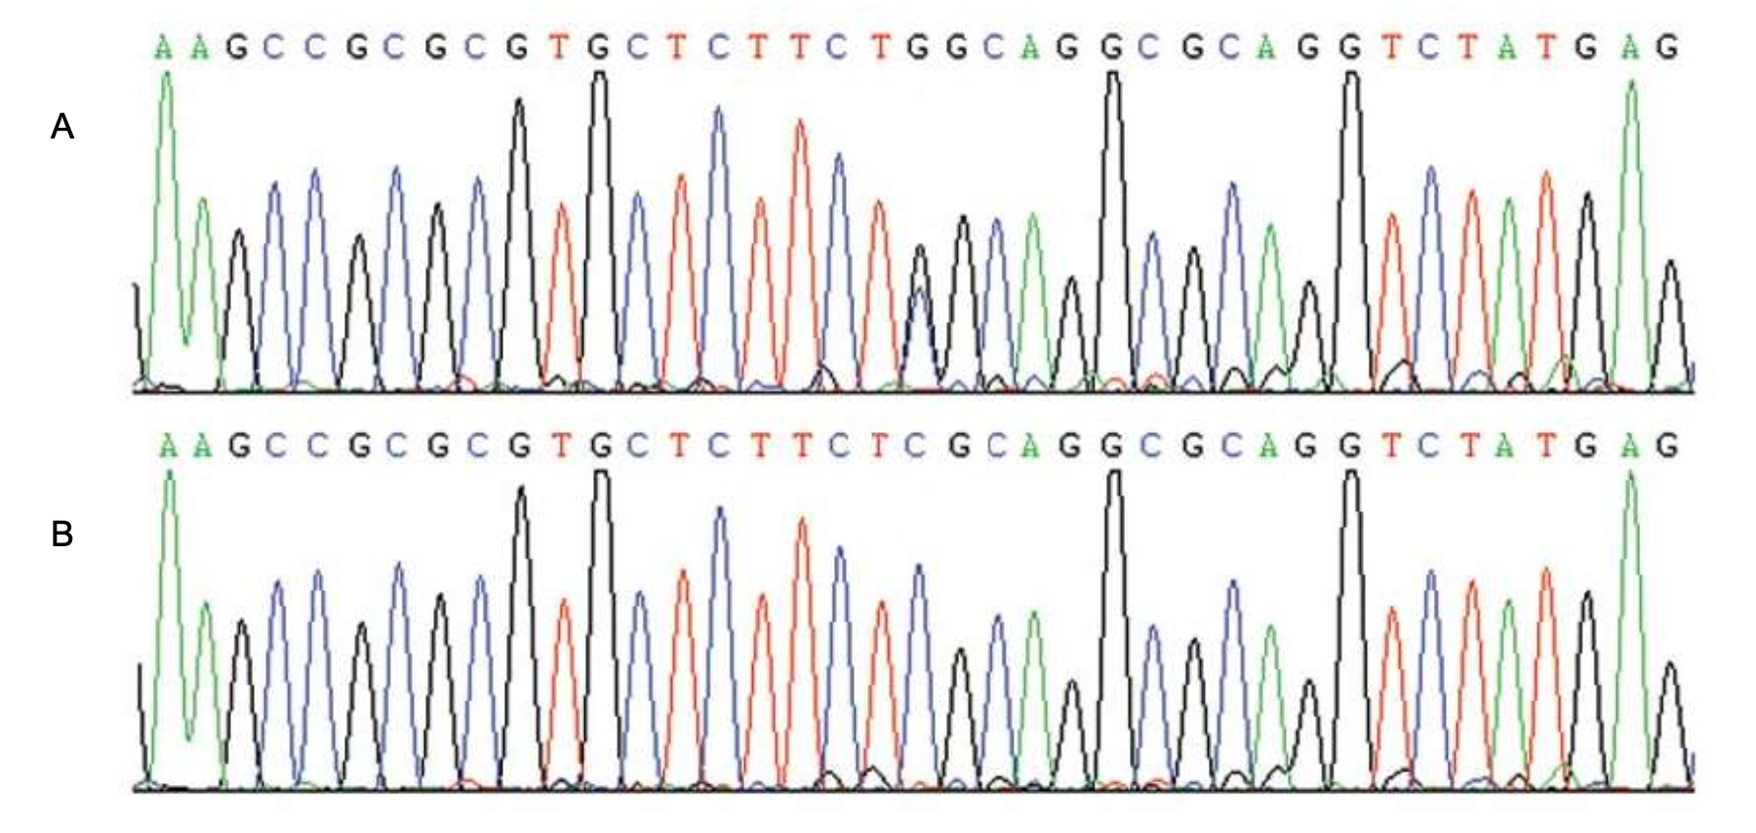

(a) Explain why the gene mutation may end up leading to no significant phenotypic changes for person B.
______________________________________________________________________________________________________________________________________________________________________________________________________________________________________________________________________________________________________________________________________________________________________________________________________________(2)

(b) Capillary gel electrophoresis method was used to create these electropherograms. Explain why there was at least 39 different sized fragments of DNA passing through the gel and detected by the computer.
______________________________________________________________________________________________________________________________________________________________________________________________________________________________________________________________________________________________________________________________________________________________________________________________________________(2)

(c) It now possible to use CRISPR/Cas9 to locate and edit this particular gene in human body cells. Explain what part of CRISPR/Cas9 would have to be designed in the lab in order to edit this particular gene in a human genome.
______________________________________________________________________________________________________________________________________________________________________________________________________________________________________________________________________________________________________________________________________________________________________________________________________________(2)

2. A small DNA sample from a crime scene was obtained and used to create a DNA profile table. The DNA sample obtained proved to have alleles 13,19 for a particular STR known as DQ1003E.

The following diagram shows three suspects with their alleles for DQ1003E.
Suspect Alleles

Badge
14, 12

13, 13

13, 19

Henrietta

Tom

(a) Is this conclusive evidence to suggest that Henrietta is guilty of the crime? Explain why or why not?
______________________________________________________________________________________________________________________________________________________________________________________________________________________________________________________________________________________________________________________________________________________________________________________________________________(2)

(b) What do the numbers 13 and 19 represent in the table above?
______________________________________________________________________________________________________________________________________________________________________________________________________________________________________________________________________________________________________________________________________________________________________________________________________________(2)

(c) STRs occur in the non-coding regions of DNA. Explain what this means.
______________________________________________________________________________________________________________________________________________________________________________________________________________________________________________________________________________________________________________________________________________________________________________________________________________(2)

(d) PCR was used before the DNA profile could be made. Describe how PCR is used to multiply the DNA that was obtained from the crime scene.
______________________________________________________________________________________________________________________________________________________________________________________________________________________________________________________________________________________________________________________________________________________________________________________________________________________________________________________________________________________________________________________________________________________________________________________________________________________________________________________________(4)
3. BCAT1 and IKZF1 are two genes that are often found in small fragments of genetic material that leak from bowel cancer tumors into the blood stream. These two genes, in the case of bowel cancer, are always highly methylated.

(a) State the name of the DNA nucleotide that is most often methylated.
______________________________________________________________________________________________________________________________________________________________(1)

(b) Describe one effect that a high level of methylation could have on a gene’s function.
______________________________________________________________________________________________________________________________________________________________________________________________________________________________________________________________________________________________________________________________________________________________________________________________________________(2)

(c) Explain the way in which a high level of methylation of genes involved in the cell cycle could lead to cancer.
______________________________________________________________________________________________________________________________________________________________________________________________________________________________________________________________________________________________________________________________________________________________________________________________________________(2)

(d) Another way in which gene expression can be altered is through ncRNA molecules. Give one example of how a ncRNA works to alter gene translation.
______________________________________________________________________________________________________________________________________________________________________________________________________________________________________________________________________________________________________________________________________________________________________________________________________________(2)

(e) tRNA plays a crucial role in the process of translation. Explain the role of tRNA.
______________________________________________________________________________________________________________________________________________________________________________________________________________________________________________________________________________________________________________________________________________________________________________________________________________________________________________________________________________________________________________________________________________________________________________(3)
4. Refer to the following graph which shows the change in energy during a biological reaction.
reactants
products
time
energy

The graph shows the change in energy during a biological reaction that has not been catalysed by an enzyme.

(a) Draw a line on the graph above to show the change in energy that would occur if an enzyme were present.
(1)

(b) Describe one way in which the active site of an enzyme is involved in increasing the rate of a biological reaction.
______________________________________________________________________________________________________________________________________________________________________________________________________________________________________________________________________________________________________________________________________________________________________________________________________________(2)

(c) Explain why certain biological enzymes have a maximum temperature in which they optimally work.
______________________________________________________________________________________________________________________________________________________________________________________________________________________________________________________________________________________________________________________________________________________________________________________________________________(2)

(d) Scientists are working on improving known biological enzymes by increasing their specificity and efficiency for industrial applications. Describe some of the key steps a scientist would need to undertake to modify and improve existing enzymes.
______________________________________________________________________________________________________________________________________________________________________________________________________________________________________________________________________________________________________________________________________________________________________________________________________________(2)

Section C: Extended Response

When answering this question you should:
- Communicate your knowledge clearly and concisely
- Use biological terms correctly
- Present information in an organised and logical sequence
- Only include information that is relevant to the question.
Note: 1 well stated point = 1 mark; (total = 6 marks)

- Advancements in biotechnology have allowed scientists to locate and transfer desirable genes from one type of organism to another, creating transgenic organisms. It is also now possible for scientists to locate and edit genes within an organism with a high degree of accuracy.

Describe one or more methods scientific use to transfer DNA from one organism to another in their creation of transgenic organisms. Also, discuss potential ethical issues related to creating transgenic organisms or using recently developed technology to edit the genes of a particular organism.

(6)

Extended Response Answer Sheet

