**COMMON CELL TYPES**

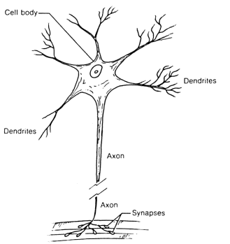

**Nerve Cells**

**Epithelial Cells**

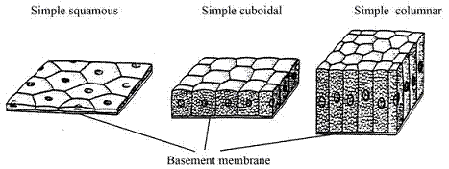

**Muscle Cells**

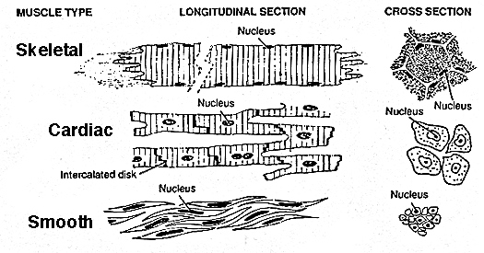

**Blood Cells (type of connective)**

