Assignment
Photosynthesis and Respiration

- Photosynthesis is the conversion of light energy to chemical energy.

  - List the substrates for photosynthesis.
_________________________________________________________
_________________________________________________________

  - Explain why the graph below is more likely to represent the limiting factor of temperature rather than CO₂. Be precise in your answer.
_________________________________________________________
_________________________________________________________
_________________________________________________________
_________________________________________________________

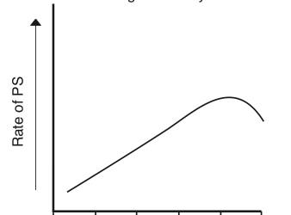

- Organisms can be divided into autotrophs and heterotrophs.

  - Explain why both use the process of aerobic respiration, and not just heterotrophs.
_________________________________________________________
_________________________________________________________

  - What is the advantage of respiration occurring in a series of small, regulated steps?
_________________________________________________________
_________________________________________________________

- Respiration can occur in the absence or presence of oxygen.

- Is this process more efficient in the presence of absence of oxygen? Explain.
_________________________________________________________
_________________________________________________________
_________________________________________________________
_________________________________________________________

- Explain why, in the process of beer making, the beer will have a large percentage of dissolved carbon dioxide.
_________________________________________________________
_________________________________________________________

- Aerobic respiration is about 40% efficient in transferring energy to ATP for cells. Explain what happens to the remaining 60%.
_________________________________________________________
_________________________________________________________

- Both alcohol formation and lactic acid formation are fermentation processes.

- Explain the key differences between the two (as far as products are concerned).
_________________________________________________________
_________________________________________________________
_________________________________________________________
_________________________________________________________

- Sprinting relies heavily on a different type of respiration than long distance running. Explain why this makes sense.
_________________________________________________________
_________________________________________________________
_________________________________________________________
_________________________________________________________
_________________________________________________________
_________________________________________________________

- List 3 key areas in an organism’s lifespan that require energy in large quantities.
_________________________________________________________
_________________________________________________________

