Investigation – Exemplar Lab Report

How Temperature

Affects the Growth

of Tomato Plants



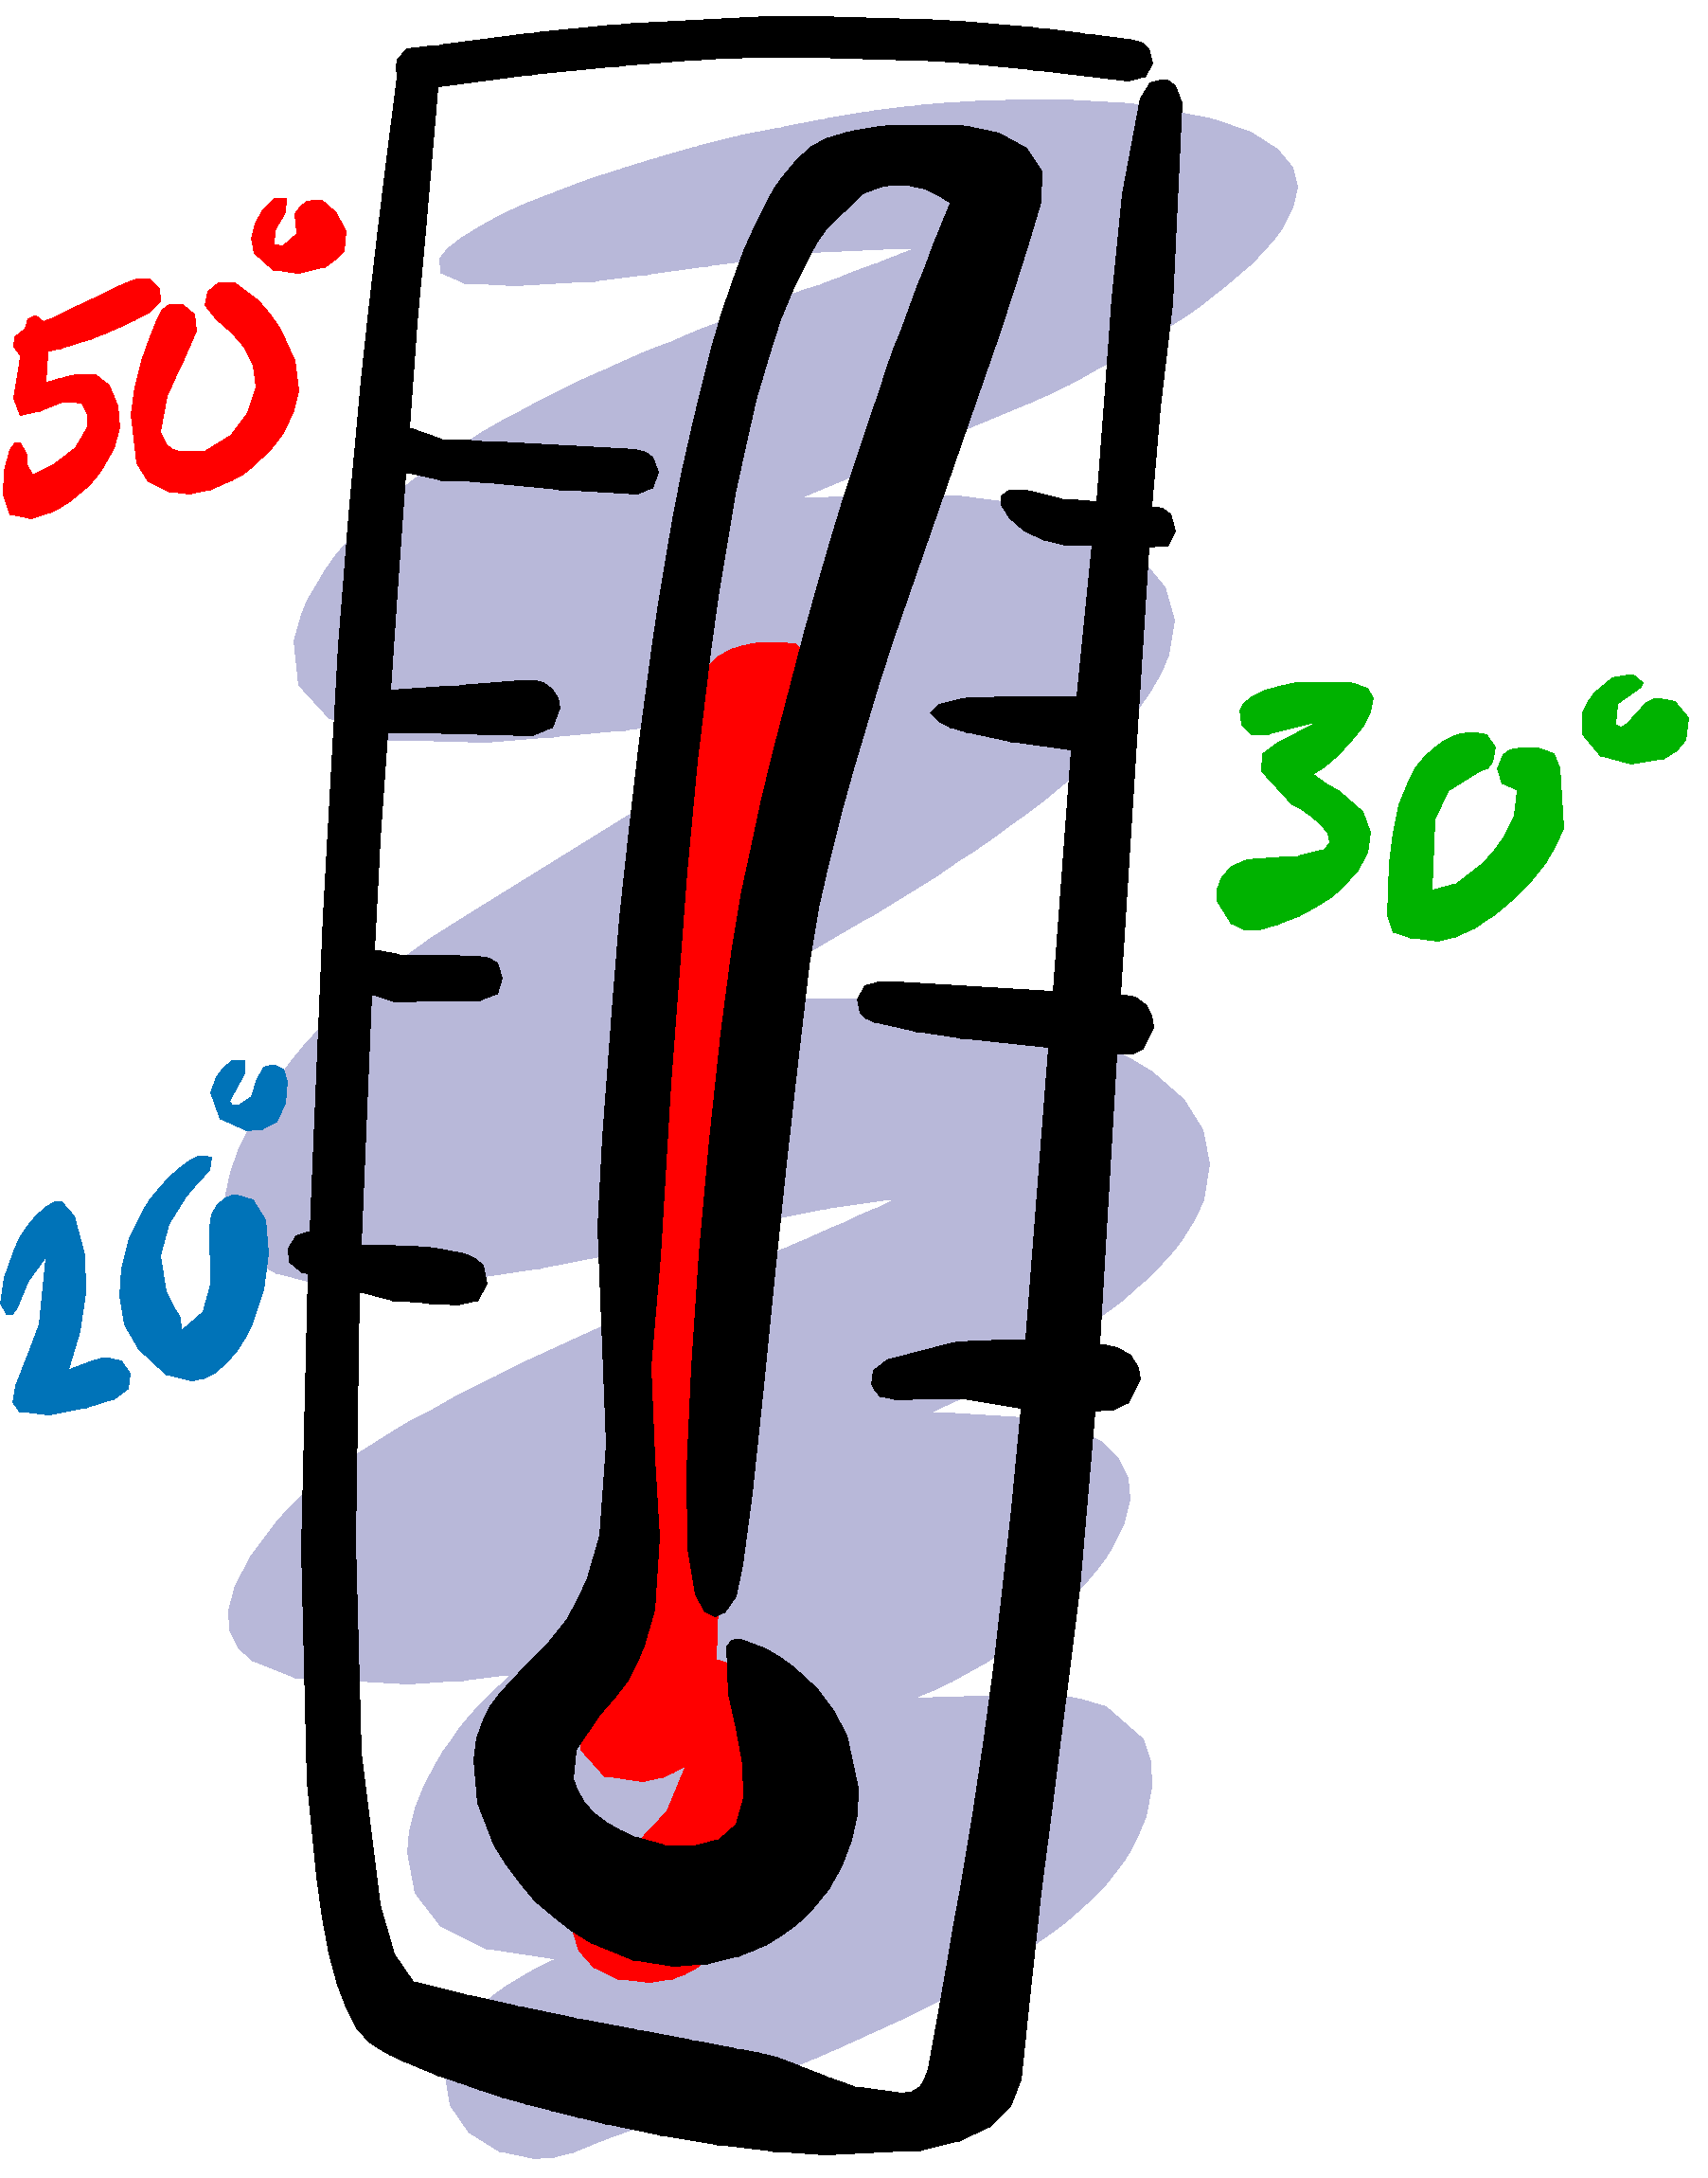

**Introduction & Aim**

Growing tomatoes is an important industry in many countries. It is important to know the best conditions for growing tomatoes in order to make the most out of their production. To determine how temperature affects the growth of tomato plants, and to find out which temperature is best.

**Hypothesis**

I think the tomatoes will grow best at 35oC because this is warm but not hot enough to kill the plant. If it is colder it will grow less because it will be trying to keep warm instead of growing. Above 35oC the plant may be stunted because it is damaged from too much heat.

**Variables**

**Independent variable** (what we changed) - growing temperature

**Dependent variable** (what changed as a result and that we measure) – plant height (cm)

**Controlled variables** (what we kept the same)

* Amount of sunlight (controlled by growing room timers) – so that…
* Type of soil – in order to…
* Amount and timing of watering – because…
* Measuring tape – use the same one because…
* Number of seeds planted in each pot – 6 – because…
* How deep the seeds were planted (2cm) – because…
* How far apart the seeds are from each other (4cm) because…
* Type of seeds because…

**What cannot be controlled?**

* The quality of the seeds – there might be ‘duds’ in the packet
* The drainage of the soil – because it is hard to control the composition of the soil so it all drains the same.

**Materials**

* 6 clay pots of the same size
* Badgerific Potting mix – 10kg bag
* 6 science lab thermometers
* 6 temperature and light controlled growing rooms
* 36 Romano tomato seeds
* Measuring tape
* Watering can

**Safety**

🗹 be careful not to breath in the dust from the potting mix

🗹 be careful not to touch the heating element in the growing room – might get burned

**Method**

1. Make sure that each growing room is set up to the correct temperature: 5oC, 15oC, 25oC, 35oC, 45oC, 55oC and with the same amount of light on the timer.
2. Set up the six clay pots with the same amount of potting mix in them (about 2cm from the top of the pot).
3. Water with 30ml water in each pot to moisten the soil.
4. Poke 6 holes equally spaced apart in the soil of each pot (no more than 4cm close to each other).
5. Drop a Romano tomato seed in each hole and cover over with potting mix evenly.
6. Place a pot in the centre of each growing room.
7. Water the tomato plants with 20ml on Sunday and Wednesday at 4:00pm each week.
8. At the start of each week make any qualitative observations in a table.
9. Continue watering and observation for 4 weeks. Record the final height of the plants after 4 weeks.

**Results**

**Table 1:** Quantitative observations on the tomato plants each week.

|  |  |
| --- | --- |
| Growing Temp  ( oC) | Final Height after 4 weeks (cm) |
| 5 | 17 |
| 15 | 25 |
| 25 | 48 |
| 35 | 52 |
| 45 | 46 |
| 55 | 21 |

Graph

**Discussion**

**Analysis:**

**Describe the pattern (trend) of your graph results?**

In this space you should describe how the temperature rise changes between each of your green houses and what sort of pattern may appear on the graph. For example in the above tomato graph, the pattern reveals two low points for growing height temperature and an optimum temperature in the middle

**How do the findings relate to the hypothesis?**

Based on the results in the graph, it can be seen that my hypothesis was correct. The best temperature for the growing of the tomato plants was 35 degrees as it grew the highest over the 4 weeks. However, the temperature of 25 degrees was a very close second.

This is likely due to the fact that 25 degrees is still a warm temperature and a temperature that is fairly common to get in areas where you find tomatoes growing outside. You don’t normally find tomatoes growing in Artic or Antarctic regions because the outside temperatures are clearly too cold for them to grow much at all. This investigation showed that just having a cold outside temperature was enough to stunt the growth of the tomatoes. It is likely true that in arctic areas the decreased amount of normal sunlight would impact their growth for the worse as well.

After 35 degrees there is a fairly quick drop off in height of the tomato plants. This is probably because the heat dries the soil out too quickly for the plant and it also hurts the leaves which the plant needs to grow properly.

**Evaluation**

It was easy to control the variables in this lab, which means that the results are probably pretty reliable. There was not a whole lot of room for making mistakes or for errors to take place. This means that the results are accurate overall.

One way this lab might have allowed for errors is the way in which the water was poured onto the pots. In two of the pots the water was poured on really fast in week 1 and it made the seeds change their position and a few came to the top of the soil and they had to be moved around and covered again. This may have affected the results as it disturbed the seed and likely made it grow slower. This happened to the seeds in the 15 degrees pot.

This could be improved by ensuring a soft sprinkling water can is used for each one. This will mean the soil and seeds will not be disturbed and will grow more consistently.

**Conclusion**

This investigation confirmed the hypothesis and was able to accurately demonstrate that tomatoes grow best in temperatures around 35 degrees. Too much cold or heat will stunt their growth.

**Does it apply to real life?**

This investigation will help farmers to grow their tomatoes more efficiently. If farmers are able to make sure they grow tomatoes in 35 degrees and keep the temperature as close to this, their tomatoes will be stronger and grow better which will mean they get more tomatoes and better tasting ones. This may help them to make more money in the long run.