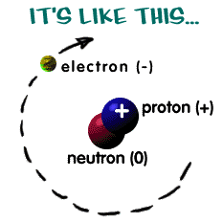
Atoms of Elements

- Classify the following as either metals (M) or non-metals (N):

  - Carbon _____
  - Fe _____
  - Cu _____
  - Chlorine _____
  - P₄ _____
  - Gold _____
  - Nickel _____
  - He _____

(8 marks)
- Of the elements listed above which one(s):
  - Exist as monatomic? __________
  - Form molecules? __________
  - Form metallic lattices? __________
  - Form Non-metallic lattices? __________
  - Would be malleable? __________
  - Would be on the RHS of the Periodic Table? __________
  - Would conduct electricity? __________

(7 marks)

- Carbon can form many different types of lattices. Graphite and diamond are two examples of how carbon atoms can be arranged to produce very different substances. Briefly research the difference between diamond and graphite, and summarize your findings below on the back of this sheet. BE NEAT.
(6 marks)

- Answer the following questions about atoms and their parts:

  - How many protons does F have? ________
  - How many neutrons does Ar have? ________
  - How many neutrons does Ruthenium have? ________
  - How many protons does Barium have? ________
  - How many neutrons does Ytterbium have? ________
  - What element has only one proton? ________
  - What element has 58 neutrons and a mass of 102.9amu? ________
  - What element has 14 neutrons and a mass of 28amu? ________

(8 marks)

