Revision 1 QUESTIONS

Topic 1: Materials and Their Atoms

  - Calculate the molar mass of Magnesium Silicide (Mg₂Si).
  - Hence calculate the number of moles in 0.700g of Magnesium silicide.
- There are 0.1198 moles in 7.00g of sodium chloride.
Calculate the molar mass of sodium chloride
- Carbon dioxide (CO₂) has a molar mass of 44.01 g.mol⁻¹
Calculate the mass of 2.335 moles of carbon dioxide.
- State the name for the:
  - Horizontal rows on the periodic table
  - Vertical columns on the periodic table
- Define the term electronegativity
- Why does chlorine (Cl) have a higher electronegativity than Silicon (Si)? (can use a diagram)
- Why does Phosphorus (P) have a smaller atomic radius than Magnesium (Mg)?
- Elements from Group 1 on the periodic table all have one valence electron and react explosively with water. Why does the reactivity of these elements increase down the group on the periodic table?
- Label the s, p, d, and f blocks of the periodic table
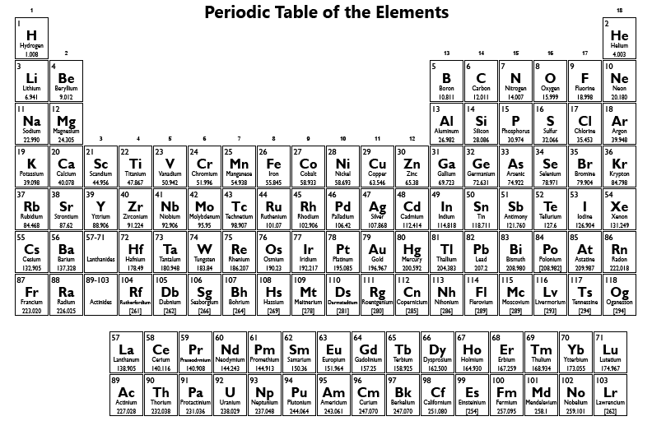

Topic 2: Combining Atoms
- What are the three types of primary bonding?
- State the primary bond that forms between the following atoms: Give reasons for your answer
a) Sodium and chlorine
b) Sodium and lithium
c) Iodine and bromine
- Why are metals good conductors of electricity?
- A mystery substance can conduct electricity well as a liquid but struggles to conduct electricity as a solid, what type of substance is it most likely to be? Why can it conduct electricity in liquid form but not as a solid?
- Billy runs an experiment with a mystery substance, he finds out that the substance can conduct electricity but he struggles to melt the substance. What types of substance did Billy have?
- What makes up ionic compounds and what shape is an ionic compound?
- What type of compound is the diagram below? What are its properties?
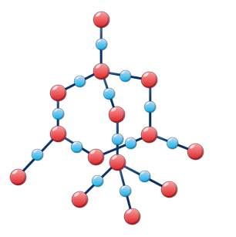

- What is a metallic bond?
- What are the properties of a metallic bond?
- Why do metallic substances possess high melting and boiling points compared with molecular substances?
- What is an ionic bond?
- What are the properties of an ionic bond?
- What shape do ionic bonds form (molecule or lattice)?
- What charge does Sodium Iodide (NaI) possess?
- Write the electron configuration (using subshell notation) for Titanium
- What is the special rule for Chromium and Copper electron configuration in subshell notation?
- What is a covalent bond?
- If you were to draw on a periodic table a line of best fit showing the electronegativity trend, how would it go?
- Why are covalent bonds between different elements polar?
- Within dihydrogen monoxide, which element is partially negative and which is partially positive?
- What are the two different types of covalent compounds, and why are they different?

Topic 3: Molecules
- What does VSEPR stand for? And what is it used for?
- Draw the structural formula of H₂O
- Draw the Electron-dot structure of COCl₂
- Name and Explain the shape of the COCl₂
- Draw the structural formula of SO₃

